Foundation GCSE Mathematics Non Calculator

- A point lies on the graph with equation y = x² - x The x-coordinate of the point is −3

Circle the coordinates of the point. (−3, −12) (−3, −6) (−3, 6) (−3, 12)
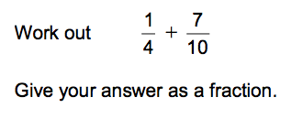
2.)

3.) A shopkeeper uses this formula to work out the cost of bags of oranges.
C = 1.7 C is the cost in £ n is the number of bags
Work out the cost of 5 bags.

4.) Ajit is a barber. He charges £4 for a haircut.
He charges 20% extra for hair gel.
One day 52 customers have a haircut. 16 of these ask for hair gel.
Work out the total amount that Ajit charges his customers that day.

5.) By rounding each number to 1 significant figure, estimate the answer to
57 × 12.3
55.53
You must show your working.
6.) The air pressure in a tyre measures 11.4 bar.
Air is leaking out at the rate of 0.3 bar per day.
Assume that the air continues to leak at the same rate. After how many days will the pressure measure 8.7 bar?

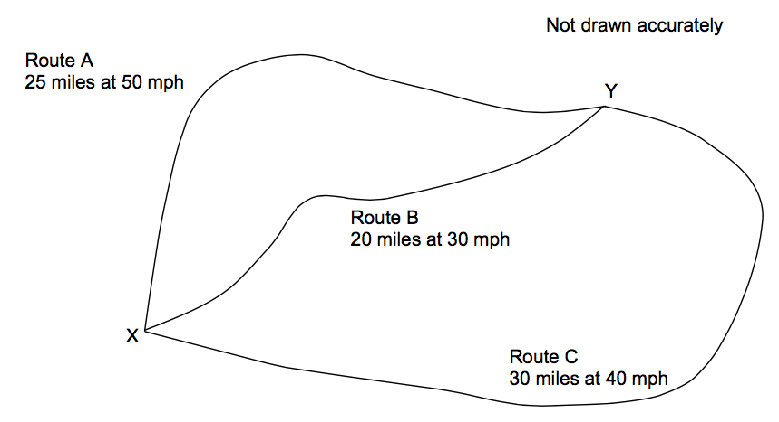
7.) Which route is the shortest? Show your working out

8.) Below is a parallelogram and AC = AB. Show that x = 16
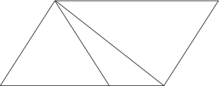

A
x 70

56
B C

