Homework due 17th January Foundation GCSE Mathematics Calculator

1 | Which is NOT a cube number? | 1 | 8 | 9 | 27
2 | Add -5 and -2 together | -7 | -3 | 3 | 7

- Write down all the whole numbers between 71 and 91
that have exactly two EVEN digits.

……………………………………………………………………………………………………………………………….
4.) Katy is facing North. She does a quarter turn clockwise.
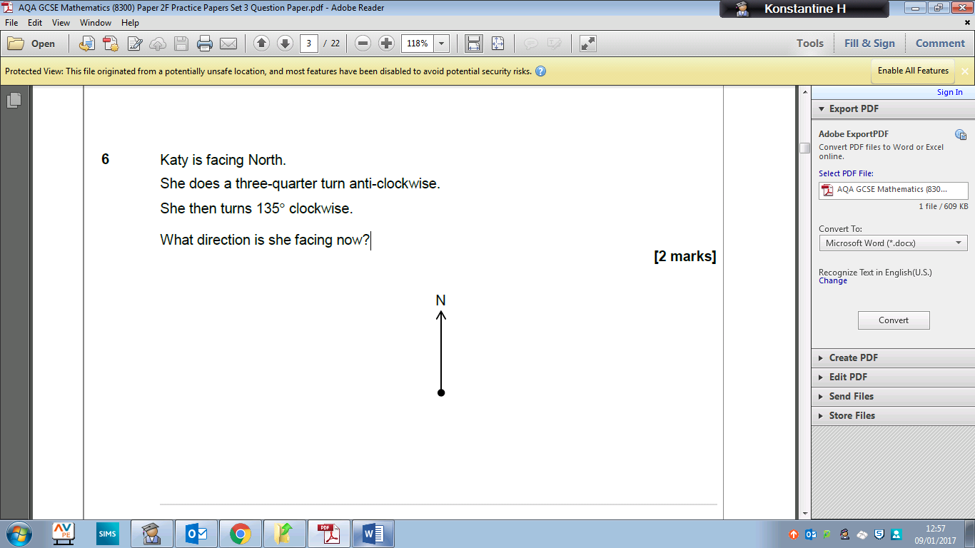
She then turns 225° anti-clockwise. What direction is she facing now?

5.)
Simplify: 3a – 4b + 6a + 3b
………………………..
Expand: 3(a – 2b)
………………………..
Factorise: 3a + 6b
………………………..

6.) Jo sold 153 mugs. One third of the mugs were small. The rest were large.
Jo made a profit of £2 on each small mug.
She made twice as much profit on each large mug.
Work out her total profit.

7.) Write down the integer values of x where 5 ⩽ x < 9

……………………………………………………..
8.) Increase 400 by 37%

…………………………………………………….
9.)
