Homework due 24th January Foundation GCSE Mathematics Calculator

1 | What the probability of rolling a number greater than 2 on a fair dice? | 1/2 | 2/3 | 1/6 | 5/6
2 | Solve 4x = 24 | 20 | 28 | 6 | 96

- At the restaurant, Ruth orders food for £17.10 and drink for £3.40
She uses this voucher.
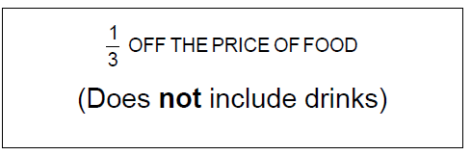
After the voucher has been used, 15% service charge is added.
Work out the final bill.

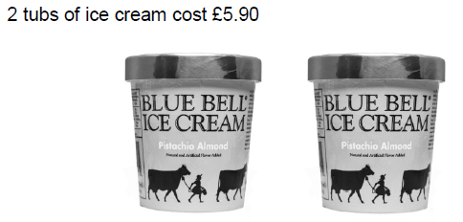

What would 7 tubs cost?

- Zoe’s password is made up of four different digits. She remembers it as two 2-digit numbers. The first 2-digit number is a prime number between 20 and 30
The second 2-digit number is a square number between 30 and 70
List all her possible passwords.

5.) A house is being built. 6900 bricks will be laid.
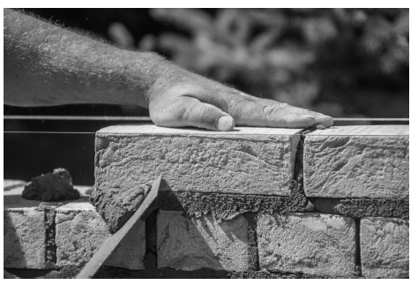

Three bricklayers will each lay 460 bricks per day
each be paid £124 per day.
How much in total will they be paid?

6.) Work out the highest common factor (HCF) of 12 and 20

Work out the lowest common multiple (LCM) of 6 and 15

7.) 240 people go to a rugby match.
183 of the people support the home team.
The other people support the away team.
162 of the supporters are male.
45 of the away supporters are male.
Complete the frequency tree.
