Homework due Tuesday 21st March Foundation GCSE Mathematics Calculator
- I take my car into get repaired and two garages are offering the following rates:
 | Labour Per Hour | Parts
Garage A | £38 | £101
Garage B | £46 | £82

Which offer is cheaper if my car needs 3.5 hours of work?

[4 Marks]
- An Isosceles triangle has one angle of 65◦
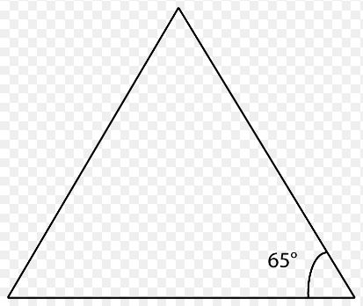

What are the angles of the two possible triangles?

65◦, …….., ……… 65◦, …….., ………

[3 Marks]

- Circle the correct answer

1 | Name a ten sided shape | Hexagon | Decagon | Nonagon | Pentagon
2 | How many lines of symmetry in a rectangle? | 1 | 2 | 4 | 8
3 | The order of the rotational symmetry of a square is… | 1 | 2 | 4 | 8

[3 Marks]
- Simplify the following:

- 7x – 2y – 4x – 5y

- 3m – 3p + 4m – 2p

[4 Marks]

- A caretaker is putting out chairs in a hall for an assembly. Each row has to have the same number of chairs and a row cannot fit more than 14 seats. The hall cannot fit more than 17 rows and the caretaker has to put out 195 chairs.
How many seats are in each row?
How many rows does the caretaker need to put out?

Number of seats per row …………
Number of rows ………

[5 Marks]
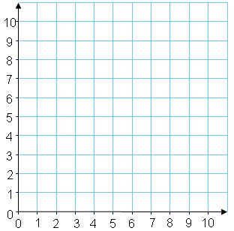
- Find the missing co-ordinates that makes the shape a parallelogram

(………, ………)

Total out of 20 …………. = ……………%

