Multiple Choice

Qu | Question | A | B | C | D
1 | 23² | 25 | 46 | 529 | 592
2 | $\sqrt{582}$ to 2dp | $$\sqrt{582}$$ | 24.12 | 291 | 241
3 | 13% of 500 | 13 | 513 | 53 | 65
4 | $\sqrt[3]{51}$ to 1dp | 17 | 48 | 3.7 | 3.71
5 | 4(2.6 + 9.3) to nearest whole number | 238/5 | 47.6 | 47 | 48
6 | 3⁵ | 15 | 125 | 8 | 243
7 | (5 x 10⁴) ÷ (4 x 10²) | 125 | 1250000 | 5.4 | 5400
8 | $\frac{3}{25}$ x $\frac{7}{13}$ as a decimal to 2dp | 0.6 | 21/325 | 0.065 | 0.1
9 | What is 4.3% of 2000 | 4.3 | 2004.3 | 2430 | 86
10 | $\frac{13 ×4.9}{8.5}$ to 1dp | 7.49 | 637/85 | 7.5 | 637
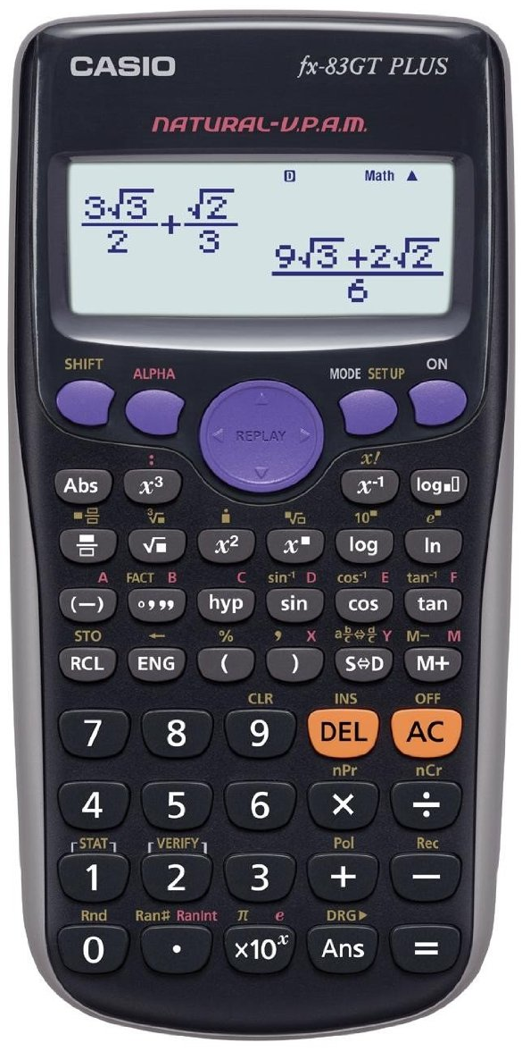

Multiple Choice

Qu | Question | A | B | C | D
1 | 23² | 25 | 46 | 529 | 592
2 | $\sqrt{582}$ to 2dp | $$\sqrt{582}$$ | 24.12 | 291 | 241
3 | 13% of 500 | 13 | 513 | 53 | 65
4 | $\sqrt[3]{51}$ to 1dp | 17 | 48 | 3.7 | 3.71
5 | 4(2.6 + 9.3) to nearest whole number | 238/5 | 47.6 | 47 | 48
6 | 3⁵ | 15 | 125 | 8 | 243
7 | (5 x 10⁴) ÷ (4 x 10²) | 125 | 1250000 | 5.4 | 5400
8 | $\frac{3}{25}$ x $\frac{7}{13}$ as a decimal to 2dp | 0.6 | 21/325 | 0.065 | 0.1
9 | What is 4.3% of 2000 | 4.3 | 2004.3 | 2430 | 86
10 | $\frac{13 ×4.9}{8.5}$ to 1dp | 7.49 | 637/85 | 7.5 | 637

