Problem Solving booklet


Name …………………………………..
Qu | Teacher Comment
1
2
3
4
5
6
7
8
9
10
11
1.) BIDMAS
Find at least one way to put in some operations signs (+,−,×,÷) to make these digits come to 100.
1 2 3 4 5 6 7 8 9 = 100
Use the box below to attempt the problem
Use the 2nd box to discuss what you learnt as you progressed through the problem

2.) Estimation
There is a very popular talent show on television. Four judges vote on each act they see. Last year, about 182 000 people (or acts) auditioned for the first round of the show.
If the judges saw every person who auditioned (which they don’t!), about how many weeks would this take?
What other information do you need to answer the question?
Make this information up, by making sensible guesses. Explain your guesses

Use the box below to attempt the problem
Use the 2nd box to discuss what you learnt as you progressed through the problem

3.) Remainders

Some students (fewer than 100) are having trouble lining up for a school production. When they line up in 3s, two people are left over. When they line up in 4s, three people are left over. When they line up in 5s, four people are left over. When they line up in 6s, five people are left over. How many students are there in the group?

Use the box below to attempt the problem
Use the 2nd box to discuss what you learnt as you progressed through the problem

4.) Money

A cinema has 100 seats. Show how it is possible to sell exactly 100 tickets and take exactly £100 if the prices are: £10 for adults, 50p for pensioners and 10p for children
Is there only one solution?

Use the box below to attempt the problem
Use the 2nd box to discuss what you learnt as you progressed through the problem
5.) Area

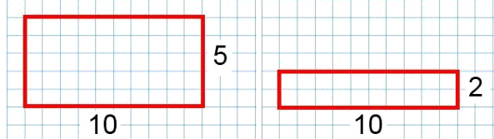
The 1st rectangle has a perimeter of 30 units & an area of 50 units². The 2nd rectangle has a perimeter of 24 units & an area of 20 units². Is it possible to find rectangles with the same numerical value for their area and perimeter?

Use the box below to attempt the problem
Use the 2nd box to discuss what you learnt as you progressed through the problem

6.) Total

Can you arrange the digits 1, 2, 3, 4, 5, 6, 7, 8, 9 into three 3-digit numbers such that their total is close to 1500?
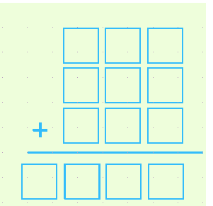
You might like to think about how many different ways there are of getting as close as you can to 1500

Use the box below to attempt the problem
Use the 2nd box to discuss what you learnt as you progressed through the problem

7.) Five

How many six-digit numbers are there which DO NOT contain a 5?
EG: 450,067 contains a 5…. 342,786 doesn’t.

Use the box below to attempt the problem
Use the 2nd box to discuss what you learnt as you progressed through the problem

8.) Coins

Adam has three coins in his pocket and they all different from each other. Ben has three coins in his pocket and they are all the same as each other. Adam has half as much money as Ben. What are the coins they each have?

Use the box below to attempt the problem
Use the 2nd box to discuss what you learnt as you progressed through the problem

9.) Zogs and Zeps

There are two types of Aliens; Zogs and Zeps. They like to wear shoes like humans. Zogs have 3 legs and Zeps have 7 legs. The shopkeeper has 52 pairs of shoes and wants as many Zeps and Zogs to have shoes on their feet with no shoes leftover and no feet left bare. How many Zogs and Zeps could be included?

Use the box below to attempt the problem
Use the 2nd box to discuss what you learnt as you progressed through the problem

10.) Taxi Fare

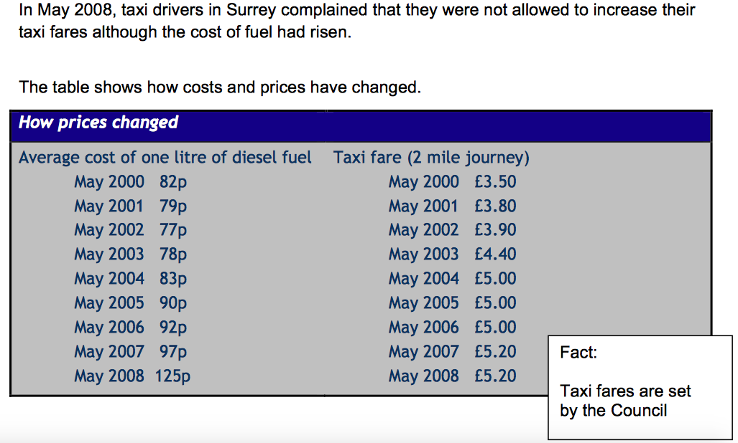

Use the box below to attempt the problem
Use the 2nd box to discuss what you learnt as you progressed through the problem

11.) Preparing a Meal
