
Indices
I used the following as a starter…
Which is bigger 3⁴ or 4³ ?
Then used this at the end of the lesson

It took a while to get 4096^{0.5} and move from 8² but they found a number of answers in the end
Standard Form
Standard form lends itself well to problems like this:
How fast do you think your hair grows, in km per hour? On average, hair grows at 1.44 cm every 30 days (well, between 1cm and 2 cm anyway) how much is this per day?
per hour? so this is the length your hair will have grown by the end of this one hour lesson....
Any problem can be created using the Guiness world of records.
I used:
The world population is as of August 2016, estimated as 7,400,000,000. The United Nations estimates it will further increase by 3,800,000,000. In 2020 What would the population be then?
Students can then use a calculator and interpret the answers they get on their calculator that will most likely be in Standard Form. It is a nice way to begin the topic.
Squares/Cubes
Students in Kates lesson were a variety problems set up on desks. This works well with a set 4 group as its smaller and more manageable. The problems are varied to identify misconceptions and ensure students can visualise cubes/squares as well as evaluate.

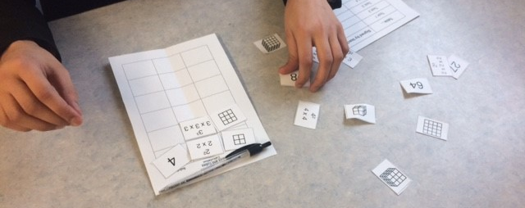
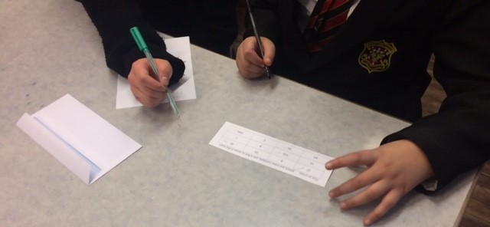
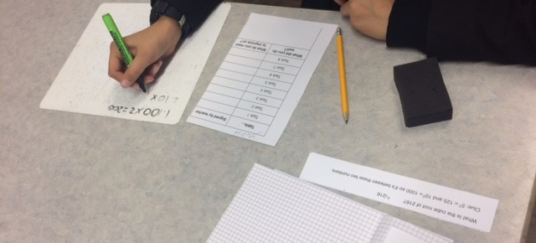

Welcome to the 10th edition of a Slice of Pi. The focus for this week is Indices and Standard Form. Topics that have been taught at Lower and Upper at the moment. I have included some resources that are attached to this email. This will be the last Newsletter of 2016 so Merry Christmas and a Happy New Year
Standard Form
Year 10 are looking at Standard form this week after reviewing Indices last week.
https://www.youtube.com/watch?v=0fKBhvDjuy0
It’s a very outdated video but still useful I think.
Issue 10
This weekly/fortnightly Maths Newsletter will hopefully give you some ideas for your teaching

A Slice of Pi

