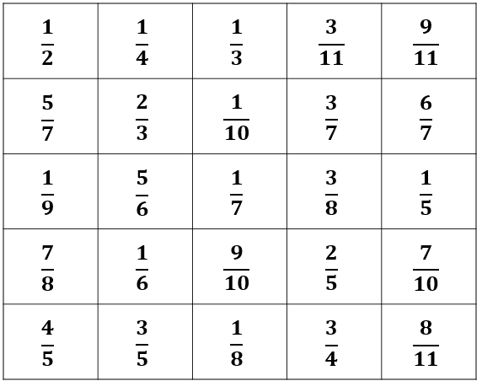

Pythagoras in 3D Check this PDF below which works through Pythagoras in 3D with good images to show too.
https://drive.google.com/file/d/0B5Rl8vLrghq_aFo3UHZZVFk4RUE/view
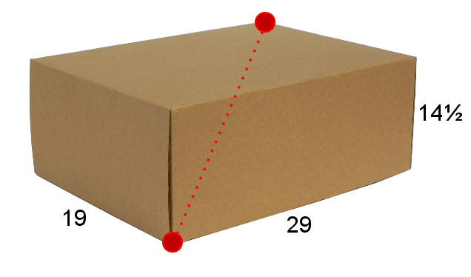
Fractions I wonder if any of your students would say 1.5/5? If they don’t, suggest it, can they find an equivalent correct fraction from it?
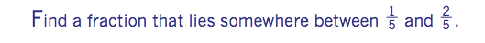
Pythagoras’ Theorem
Thank you to Sana for this Pythagoras lesson idea. She has squares ranging from 1x1 to 15x15 with the areas of the squares written inside. Students investigate the relationship of the two shorter sides and the longer side on a right angle triangle.
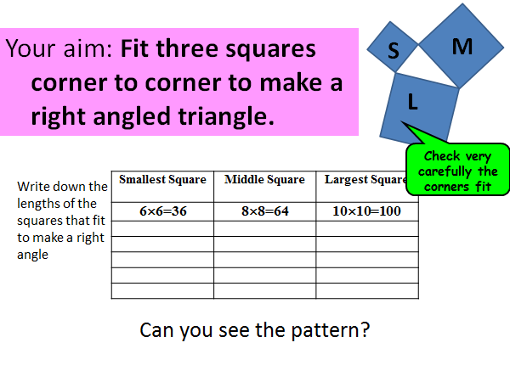

Fractions
Kate gave her students a question that asked for an equivalent fraction to say 3/8 that had a numerator bigger than 10 or that both numerator and denominator that are both even. I had a think about this and adapted it slightly and thought of other questions along these lines. They have just looked at primes, Factors etc so this revised these topics.

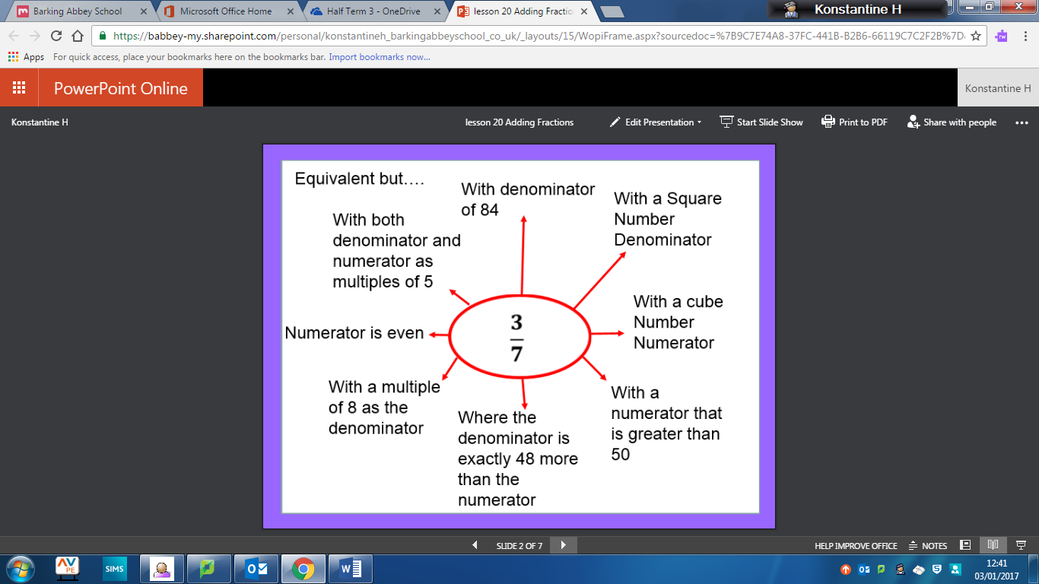

Equivalence Bingo! Year 7 liked Bingo last week. They chose 9 fractions in a 3x3 grid and I called out fractions that needed simplifying eg: 6/15. Bingo is 3 in a row
Welcome to the 11th edition of a Slice of Pi. The focus for this week is Fractions and Pythagoras’ Theorem. A topic from Upper and Lower. I have included some resources that are attached to this email. Welcome to the first Monday at work In 2017 and the first edition of the Newsletter in 2017.
Issue 11
This weekly/fortnightly Maths Newsletter will hopefully give you some ideas for your teaching

A Slice of Pi

