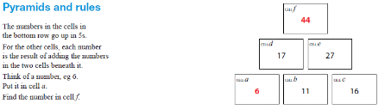

Number Machines
I spotted this on an AQA paper the other day (Nov 2015 I think) This made me think about a lesson I used with number machines.
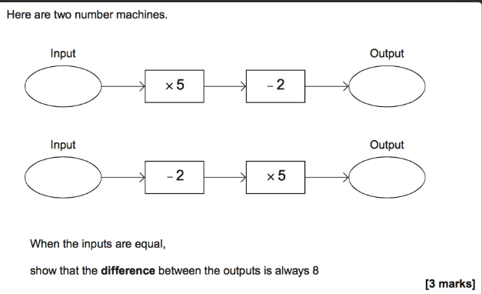

The lesson is below
Students are given a chance to look at the output of seemingly two identical machines (they usually think the outputs will equal) and discuss what has changed and you can talk about what the difference is between input and output and make a table. EG;

1 54 1 204
2 58 2 208
3 62 3 212 differs by 150

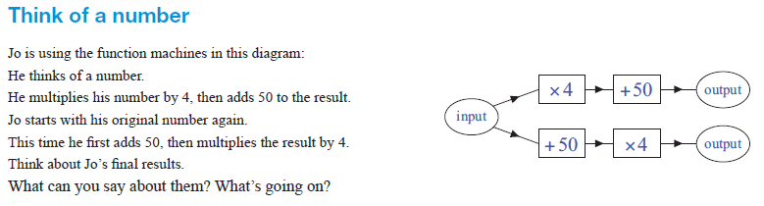
Then there’s this Question to extend students thinking
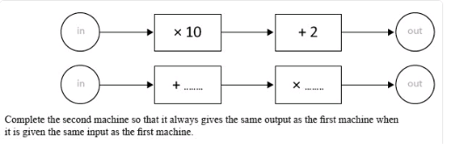

Pyramids and Rules
This is straight from ICCAMS and is one of my favourite questions to use. It gets students discussing rules, and they also love the ‘magic’ element of finding cell f from cell a. Please DON’T use this lesson with year 7 as I’ve included it for KS4 staff and this lesson will be delivered in a months’ time and you’ll ruin it for year 7 if you do
Give students time to try values for Cell A and see if they can find the missing cells. Discuss the connections Cell A has with each of the other cells. If they give you Cell A (say 6) can you tell them ‘magically’ what cell F is? (rule 4n + 20)

I will include the lesson plan with this. My year 7 who I trialled the lesson with, firstly came up with expressions which led to the rules
We then discussed why they were the same.

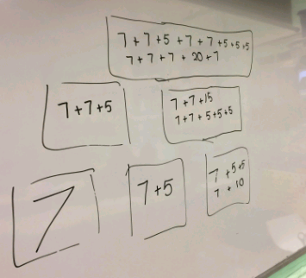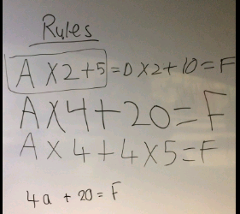

Welcome to the 12th edition of a Slice of Pi. The focus this week is Algebra especially where students are expected to form rules or equations/expressions/formulae to explain what is happening or would make a second part easier to answer.
Issue 12
This weekly/fortnightly Maths Newsletter will hopefully give you some ideas for your teaching

A Slice of Pi

