
Equivalence Bingo! It’s not the best question but any question that gets students discussing and comparing fractions is a good idea.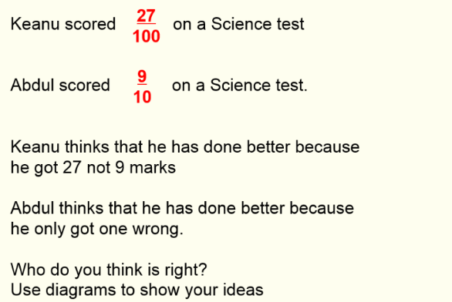
Fractions Multiple Choice Here is a Fraction Multiple Choice sheet I made for year 11. Feel free to use with any group doing fractions
See attached
See attached
Reverse Multiple Choice
I have used a number of multiple choice questions with year 11 and sometimes year 10 or 7 and the other day I wanted to use one but couldn’t be bothered to think of any in class so I gave my students the problem of creating 2 multiple choice questions related to the topic we were looking at (Percentages)

I gave them the answers;

0.4 4 40 400

I said that 40 was the correct answer.
I got some very basic questions such as;

Find 100% of 40
Find 10% of 400

Then some like this; Find Increase 10 by 300%

Percentages
I found these on Don Stewards site and although they are simple, it’s nice for students to use a proportion and use basic percentages to help them get more complicated ones. We should stress to students this methods isn’t effective time wise when it’s on a calculator paper. Too many of our students work out percentages on paper 1 or 3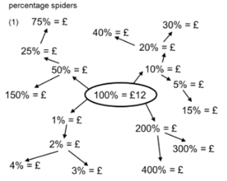
Fractions Get students to find as many ways to show who gets more chocolate
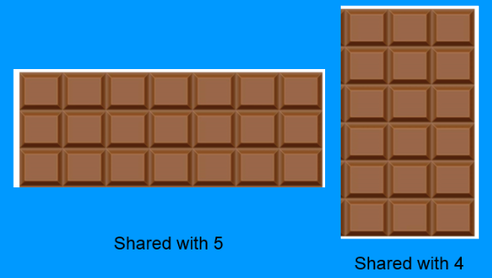

Welcome to the 13th edition of a Slice of Pi. This edition includes ideas to use with any set and any year group when looking at Fractions and Percentages. It’s a topic we are teaching year 7 at the moment and one we are constantly looking at through out KS4.
Issue 13
This weekly/fortnightly Maths Newsletter will hopefully give you some ideas for your teaching

A Slice of Pi

