
Ratio Tables A little starter that gets students viewing the ratios in two ways.
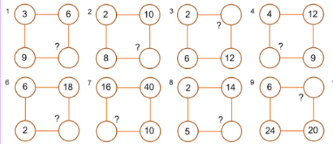
The rules are that the same ratio is used for both sides of the square and so both ratios across the square are the same.
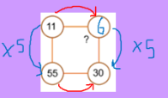

17 Times Table For any of you that looked at the 17 times table last week with their class.
https://www.youtube.com/watch?v=yXdHGBfoqfw
Here are a few ideas for follow up questions
17 x 10 = ….. so 17 x 5 = ……
17 x 3 = 51, 17 x 6 = ….. and 17 x 9 = ….
17 x 4 = 68 what is 1.7 x 4
17 x 80 = 1360 so 17 x 81 =

Comparison Questions
Comparison questions are quite popular exam questions as it gives a student a real life problem. Which would you rather buy?
Which is better Value.

This is a slightly redesigned past EDEXCEL exam question. I would slightly rephrase this and ask for as many ways to compare the two. Students get set in calculation that works for all but isn’t always the most efficient way for that particular calculation.
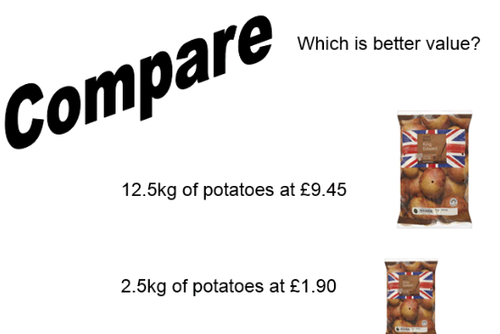

The Double Number Line
The double Number line might not be something you want to use, but it does have many uses and it can be really useful for low attainers working out more difficult problems.
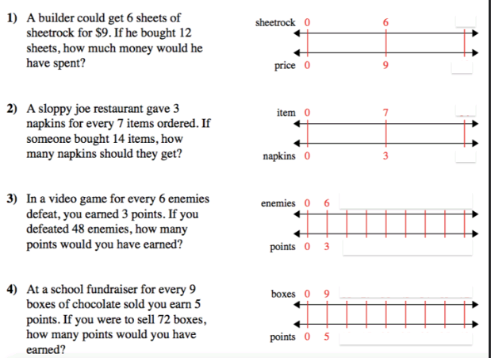
Giving a student number line to start with can help the see patterns and hopefully enable them to move across the lines as well as a long.

Welcome to the 14th edition of a Slice of Pi. As we are approaching the end of the half term I thought I’d share some resources for Ratio and Proportion. ICCAMS used Multiplicative Reasoning as a big feature of their lessons and it’s something students struggle with so we do need to address this.
Issue 14
This weekly/fortnightly Maths Newsletter will hopefully give you some ideas for your teaching

A Slice of Pi

