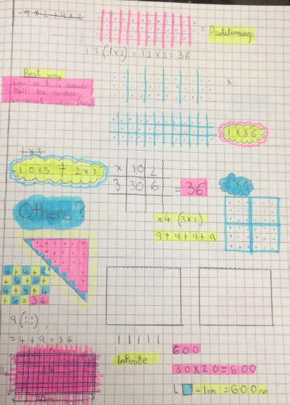
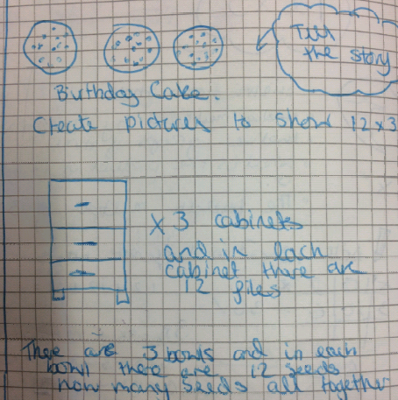
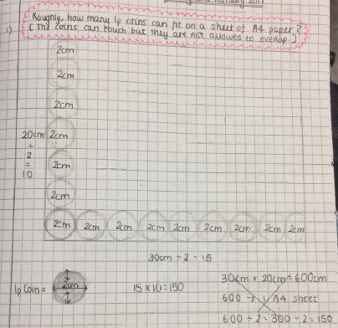
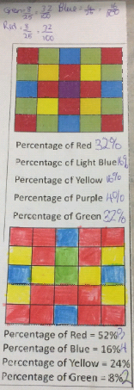
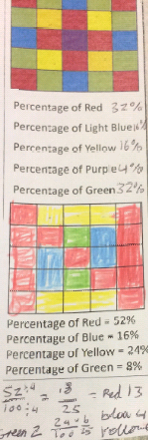
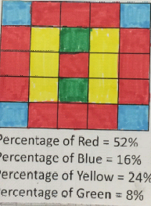
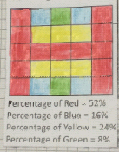

Percentages Revision
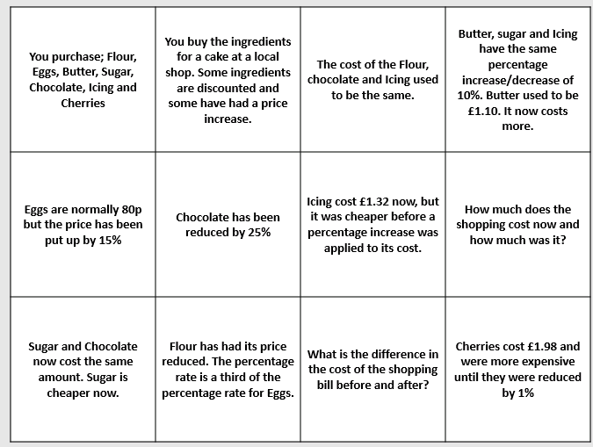
I have just made the problem above. It uses reverse percentages. I let the class work in pairs and they enjoyed trying to piece the problem together and work out which parts they needed to solve first in order to answer the question.
I know many of you know this site but;
http://prethomework.weebly.com/ it has good homework sheets, mine are there @giftedba

ICCAMs Thanks to Aman for sharing her experiences with using the ICCAMS lesson. I wanted to share some of her photos, whether with year 7 or 11, please do share any experiences you have with these lessons. I do want to hear about how they want (bad or good)

I have just made

Percentages and Symmetry
I created this problem for my students but added that I wanted them to try to create a pattern with either rotational symmetry order 2 or two lines of symmetry. They had to write the percentage shaded in the first image and shade the given percentage in the second.
Welcome to the 15th edition of a Slice of Pi. Welcome Back! This week’s edition looks at Percentages but a focus on problems involving Percentages. There are a few problems on reverse percentages and a problem I created that tests students ability to reason, problem solve and work with reverse percentages.
Issue 15
This weekly/fortnightly Maths Newsletter will hopefully give you some ideas for your teaching

A Slice of Pi

