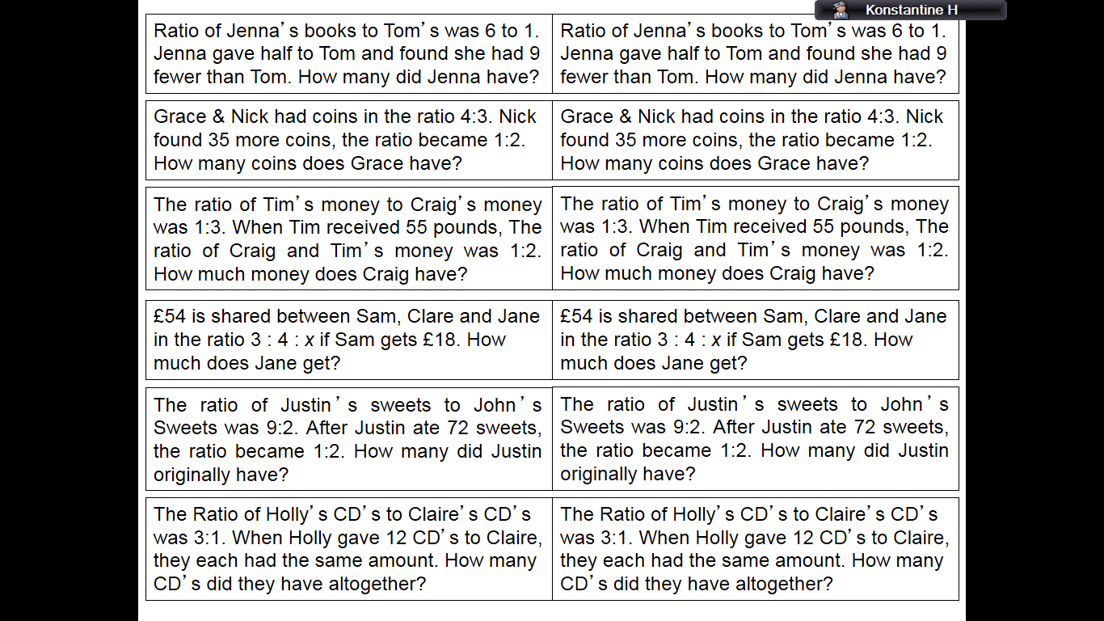
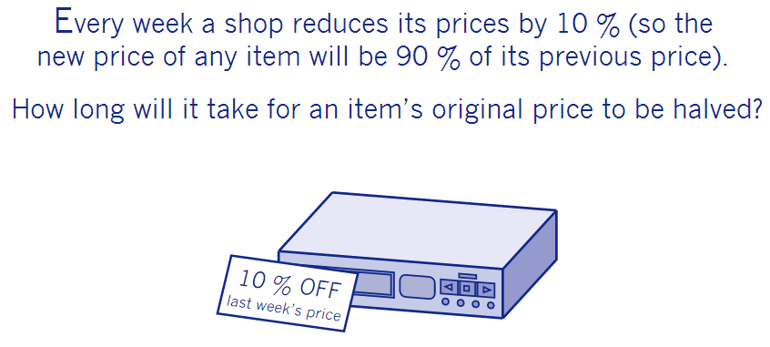
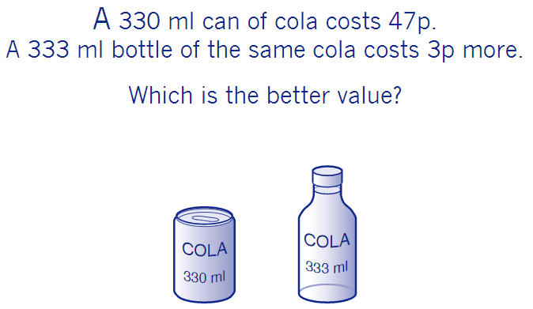
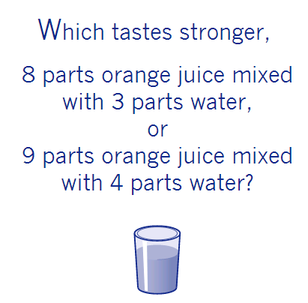

Pythagoras
If you haven’t seen the Pythagoras Pile up then here’s the link; https://www.dropbox.com/s/x2ijjcp3cbm693f/Pythagoras%20Pile%20Up.pdf?dl=0
I do find it takes a while so I made a slightly less involved version. I’ll attached the ppt copy to the email.
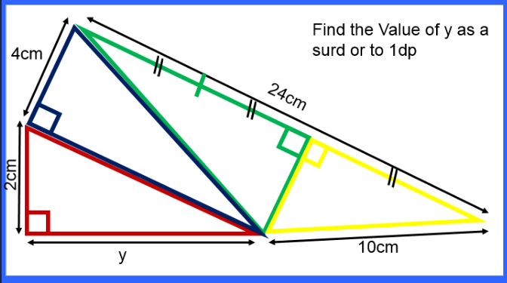
There is a trigonometry pile up too
http://www.greatmathsteachingideas.com/2012/03/12/trigonometry-pile-up/
Ratio and Proportion Problems Ratio and Proportion is being taught at KS3 and it’s a great topic to revise at KS4 so here are a few questions to consider using:

The questions below are a sample (the full set are included in the ppt attached) of some extension ratio questions that you could set your more able students in set 1/2.

I have just made

Ratio
I like this idea and you can even pour out a few drinks too, so students can actually taste the difference in the two drinks. Its called which is ‘Orangier’? Students have to compare the two drinks and decide which will be stronger
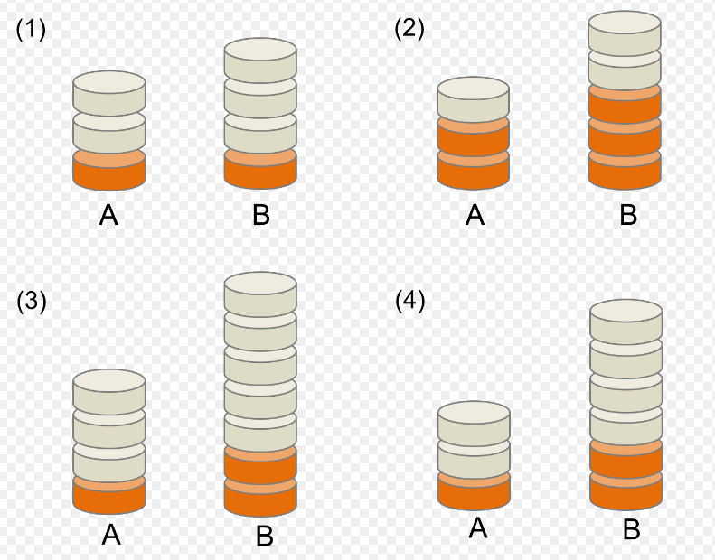
UKMT You can access problems from UKMT on diagnostic questions at this site
https://diagnosticquestions.com/UKMT
Welcome to the 16th edition of a Slice of Pi. This week’s newsletter is a mix of topics. There is Pythagoras for KS3/4 because it has been a recent topic and there is ratio and proportion because this is another current and very important topic.
Issue 16
This weekly/fortnightly Maths Newsletter will hopefully give you some ideas for your teaching

A Slice of Pi

