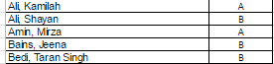

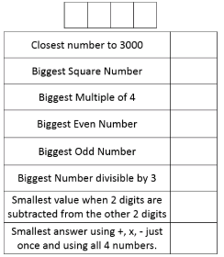
Find a number
Please see the attached.
I used it as a starter with
Year 7 and 8 last week
Year 11 Timed Questions I have been using a visible timer with year 11 and giving them roughly the same number of minutes as marks. This has encouraged them to not rush and use all the time given. It means they also stay together as a class meaning I can go through each question I write them straight after I set it.

Ratio Test Comparing
Year 7 all sat one of two ratio tests. The answers for all three questions were the same; 75, 84, 90, but interestingly the common incorrect answers (if students added) were also the same; 47, 45, 41. The questions are included in the attachments under Ratio test.
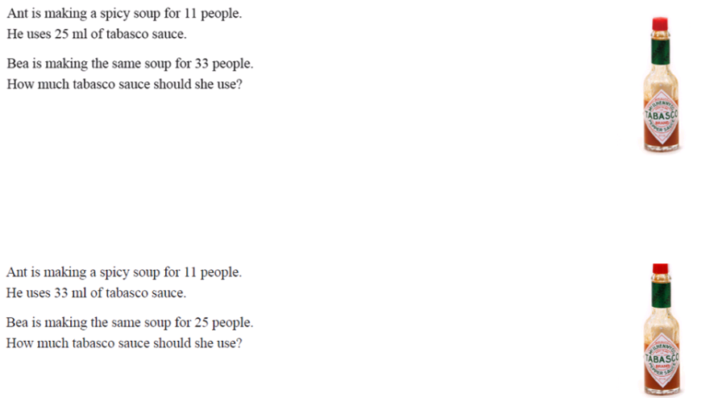
This might be a nice starter to use. Ask students to do all three slides and discuss what they notice about the answers. Do they find one question easier to answer each time? Students are more comfortable with the scalar type Questions 11 people to 33 people but not the functional relationship 11 people to 33ml of tabasco sauce.

Compare
I wrote 30 questions where students need to compare two items from either Alan or Bellas shop. The questions are all different and have different levels of difficulty. An example is included below. The question for all was the same. Which is better value? Compare and explain your answer.
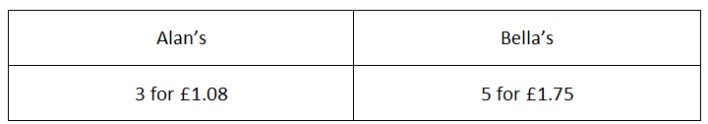
After students attempted their question, students told me the letter A or B for their answer and I had the list of correct letter in my mark book

When I took their books in next time, I marked their working out. I have included the 30 questions in the email attachments. Below are some responses. I took note and shared in class any interesting methods.
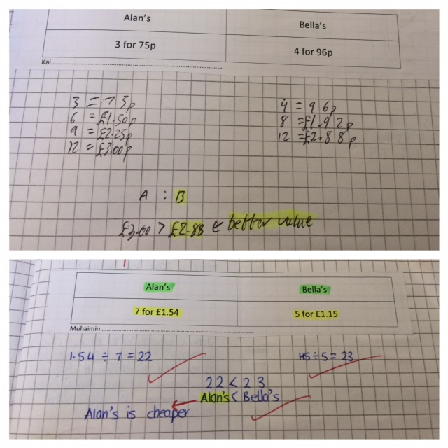
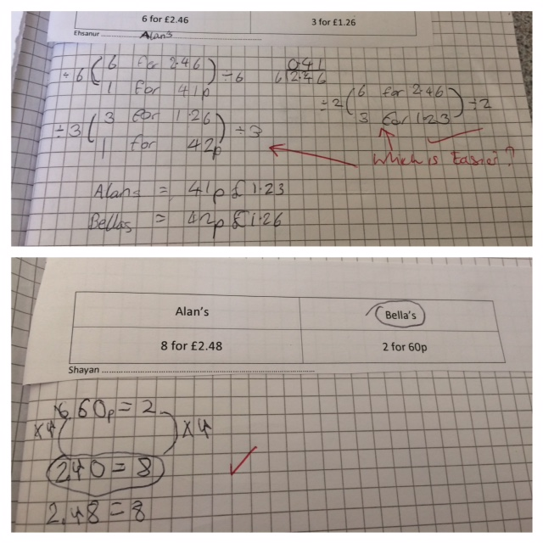

I have just made

Welcome to the 17th edition of a Slice of Pi. This weeks newsletter focusses on a few ideas I’ve been using in my year 7 and year 11 lessons last week. I think all the ideas could be used with any year group and any set.
Issue 17
This weekly/fortnightly Maths Newsletter will hopefully give you some ideas for your teaching

A Slice of Pi

