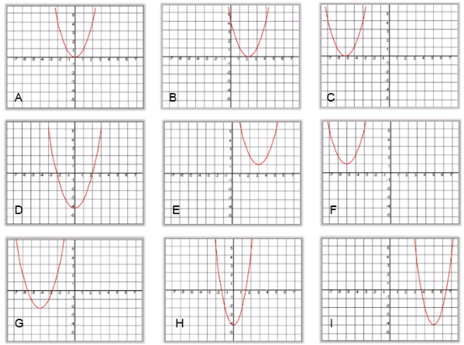
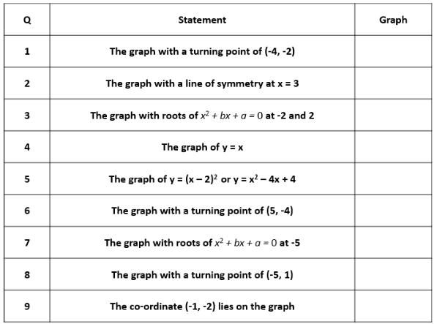

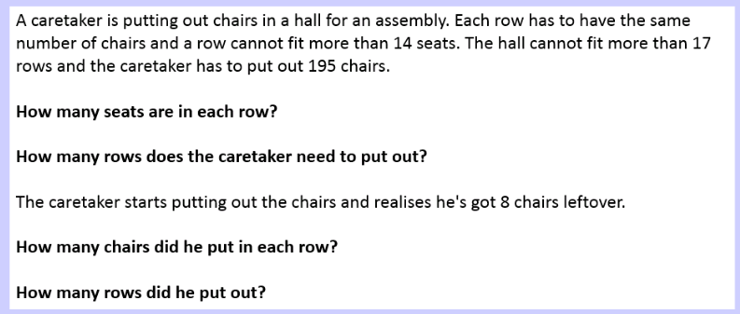
Old NFER Ratio Test Check out this link for interesting, old style questions on Ratio
http://iccams-maths.org/CSMS/images/ratio.pdf

Quadratic Graphs
This week I am going to try out these questions I’ve created with year 10 set 4, but they would make good revision questions for all sets. I want them to try to think about what the graph should look like without necessarily drawing it each time. Email me if you want a ppt copy of it
Ratio – What could the question be?
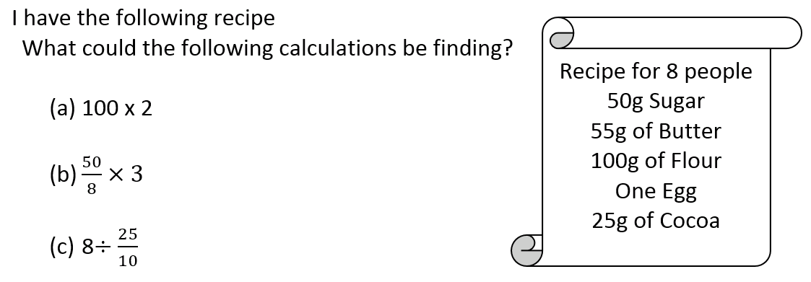
I have started including a few more questions where I give the calculation and ask students to come up with the possible question. Students found part (a) and (b) straightforward. They seemed to find the numbers in the question and then try to find what was being found using this. They struggled with (c) especially as the number of people was not a whole amount. I tried putting it into a ratio table.
 | 8 people
10g cocoa | 25g cocoa

Students could then try to see what was being calculated.

have
Rows and Seats (arrays/Prime FF)
I have been writing questions for year 11 homework that can put into practice some of the questions they got wrong in class. I also wanted to write a question my top set year 7 could try that would use some of the work they have been doing on arrays.

Year 11 struggled with this question. Some just multiplied 14 x 17 and wrote that answer down.

Some tried 195/17 or 195/14

In the end I had to remove the 14 and 17 restrictions and allow them to find numbers that would work.
One student did write 39 x 5 which was at least a step in the right direction but we had to discuss why it couldn’t be used when the restrictions were put back.

The second part was also really challenging and students didn’t attempt to find factors of 195.
Welcome to the 18th edition of a Slice of Pi. There is a lot of Ratio and Proportion in this week’s edition as this is being taught to KS3 and I’m revising some of this with year 10 and 11 at the moment.
Issue 18
This weekly/fortnightly Maths Newsletter will hopefully give you some ideas for your teaching

A Slice of Pi

