
Applications of Prime Factor Form
Just recently, whilst teaching year 10 I was aware how difficult they found it, finding the factors of a given number
I had given them last weeks problem: ‘care taker puts out 195 chairs and he wants all rows to have the same number of chairs and have no more than 14 seats and no more than 17 rows.’ They struggled with this problem because they were finding it hard to find numbers that multiplied to make 195. They found 5 was a factor but 5 x 39 was not an acceptable answer. I broke 195 up into prime factor form and showed them how to get the factors. They also were struggling with a question about finding the square root of 196 without a calculator. When I broke the number into PFF they could see the answer more clearly. This problem is quite a nice way to get students to find factors and discuss how it works.
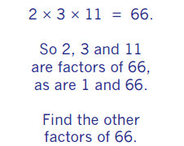

A nice problem, many connections
I like this question below…
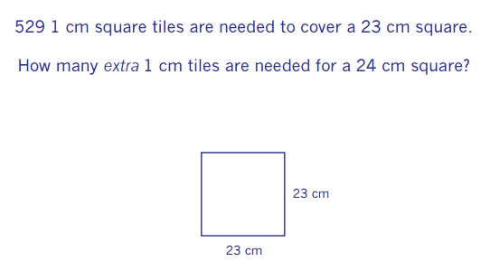

Students can use a more obvious method of 24 squared – 23 squared but then see how many can find ‘nicer’ methods that require less calculating. Can they sketch useful diagrams?
Can they find the number of squares needed for a square 1 more than 10 or 11 or 12? Is there a pattern? A rule?
It fits nicely to topics like square numbers and area but I think if you then use a follow up question of how many squares extra would you need for 46cm square you can start a discussion on scale factors and how it affects area.
It can also be related to algebra; we have 24 squared – 23 squared but what if it was a square of x length and the other square was one square longer?
How could we find the number of extra squares needed?

Last Problem…
This last problem is nice because it can be broken down simply and has many ways to solve it and many connections to topics; ratio, algebra, gradient etc Let me know how you get on with ANY of the problems, which group did you try it with? How did they solve it? How did you help them?
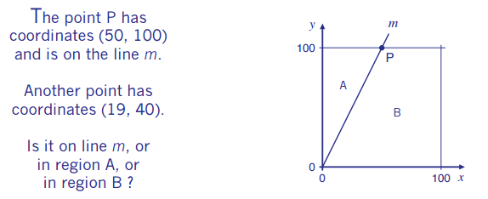

have
Welcome to the 19th edition of a Slice of Pi. I have tried to include topics that have multi-topic links. In the spirit of questions having no clear topic link I have been trying to find more of these types of questions
Issue 19
This weekly/fortnightly Maths Newsletter will hopefully give you some ideas for your teaching

A Slice of Pi

