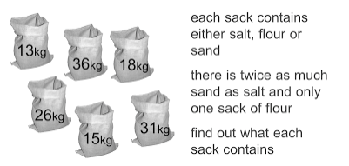
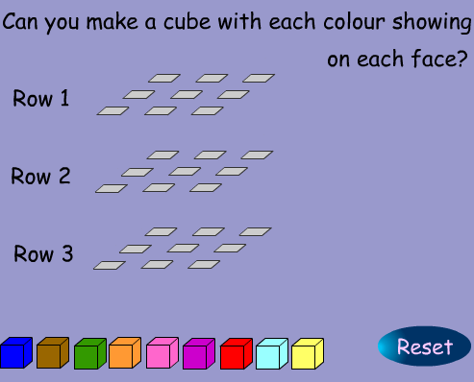
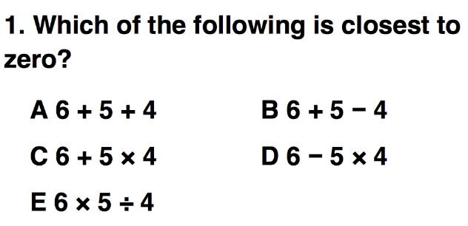

Competitions and Games
In light of the fact there are many game themed ideas here, this is the theme.
Puzzle
I came across this puzzle today and I really enjoyed solving it
Chess
I was chatting to Mohammed and Baljit about Chess Club that they are organising for Lower School Students and Baljit shared this problem from the NRICH website that she used with her year 10 set 1. It has full solutions too.
http://nrich.maths.org/768

UKMT
Kate recently reminded me just how useful the UKMT questions are for starter questions. I saw her using a question like the one below and it started conversations on Rounding and order of operations/BIDMAS.
If you want to view UKMT questions to use in class this link is excellent:
http://www.ukmt-resources.org.uk/index-tr.html

Deal or No Deal
A while ago I made this set of Deal or No Deal boxes from old paper boxes. They have proved useful for lessons on Averages and make good aids for revision. Students play out the game but in each box is a question and they use whiteboards to solve the problem and then the best explanation to the problem gets to be the contestant. Feel free to use the boxes in your lessons. They reside at Lower School at the moment.
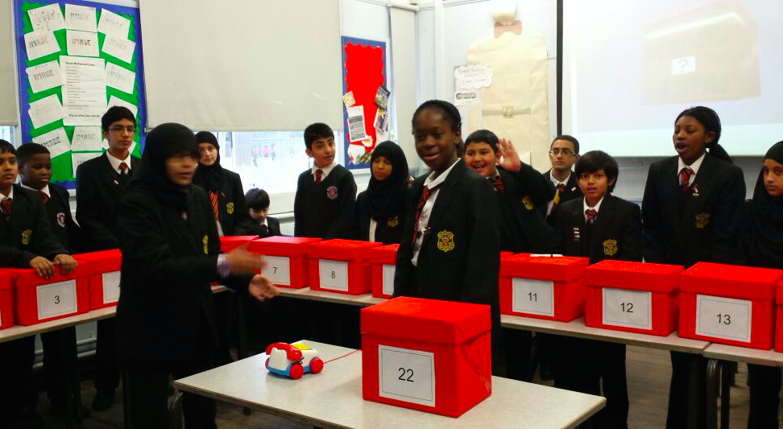
Issue 2
Welcome to the second edition of a Slice of Pi. Thank you for the feedback from my first newsletter and also a huge thank you for all the ideas and suggestions to include in this week’s newsletter. This week the theme is Competitions and Games. We have Chess Club starting up at Lower School and the school is submitting its entries to this year’s UKMT for all year groups 7-13 so it seemed like a good theme.
This weekly/fortnightly Maths Newsletter will hopefully give you some ideas for your teaching

A Slice of Pi

