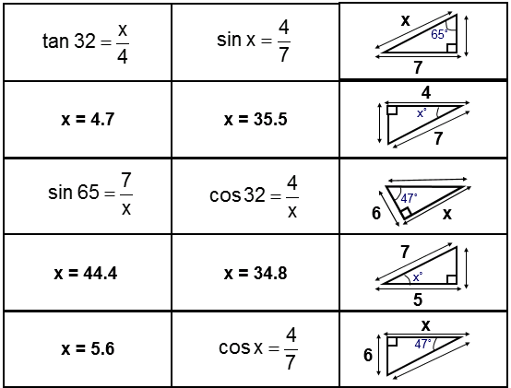

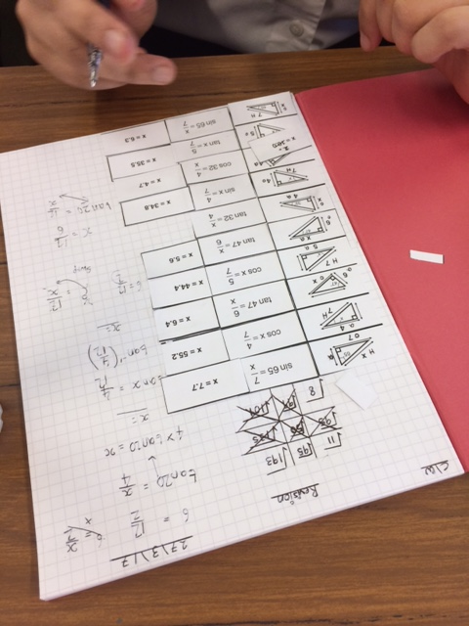
If you want to use the task below but want the original copy then email, me and I’ll happily share it. Thanks to Sana, Simran and Aman who shared experiences with some of the tasks in the past weeks (ICCAMS included)
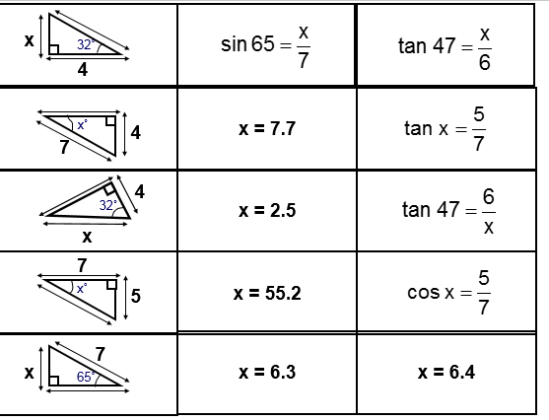

Extension: Give worded questions on the screen that students need to match the diagram to first before solving.
EG: How far off the ground is a plane that has flown 7km at an angle of elevation of 65◦? Not the best Q probably but an idea.

Issue 20
This weekly/fortnightly Maths Newsletter will hopefully give you some ideas for your teaching

The Task
Students need to match the problem/diagram with the calculation and solution. With my lower attaining groups I did ask them not to cut up the diagrams but just the calculation and solution. I taught a few lessons on trigonometry leading up to this task where I focussed on which part of the calculation students were trying to solve. So students knew, when solving this problem, they had to label the triangle, choose the correct rule, substitute and solve. Students who struggled with the task initially focussed on labelling before selecting the correct rule. I suggested with my set 4 groups that they sort the cards into piles so all Sin, Cos and Tan were in separate piles

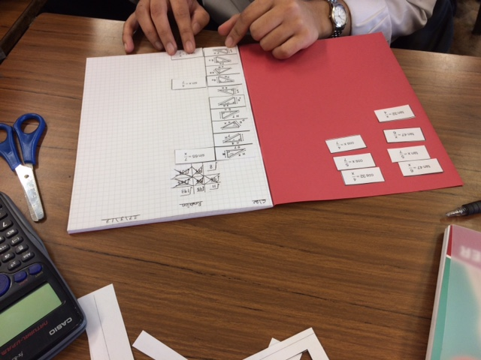

I did try and use similar numbers with all my questions so students couldn’t just look at the numbers to get the answers.
Students that were more able could move from substitution to solving, using the calculator, and even round correctly.

Some students wrote next to the diagram their initial thoughts and then checked with me before progressing. One boy said I think this is tan, because I have opp and adj labelled. He then had to substitute which can be a challenge in itself. He wrote down what he thought it was and when I checked it he could stick the answer next to his initial idea so I could see what he initially thought and he had the corrected answer next to it

have

Welcome to the 20th edition of a Slice of Pi. This weeks newsletter focuses on a task I made a few years ago and I have used it this year with a set 4 yr 10 group, revision for a yr 11 set 3 and for a yr 8 set 1 in the past.
A Slice of Pi

