

have

Area/Perimeter Game
Area and Perimeter game for 2 or 3 players. Each player chooses a colour pencil. Players take turns rolling the dice, using the numbers that they rolled to draw the perimeter of a rectangle or square & writing the area in the middle of the shape. Game ends when players run out of room to draw. Winner is the player who has used the largest area/most squares.

This is a fun game and students seem to really enjoy it and practises area/perimeter and helps them remember the difference if they are the sort to confuse them

have

Probability Games
I used this a lot at lower school but could work with KS4 set 3 and 4. You can have some good discussions on why games are bias to one player and work out the odds of winning for each player. Various methods to calculate the odds of winning can be used. In game one, you could use combinations to find the odds of getting each letter. Each game could be varied or students could vary the game to try and make it fair or fairer.
Also, students could then try and make up a game of their own that could be played. A simple game using either; coins, counters or dice.

I have included in the email a copy of the games for handout for students.
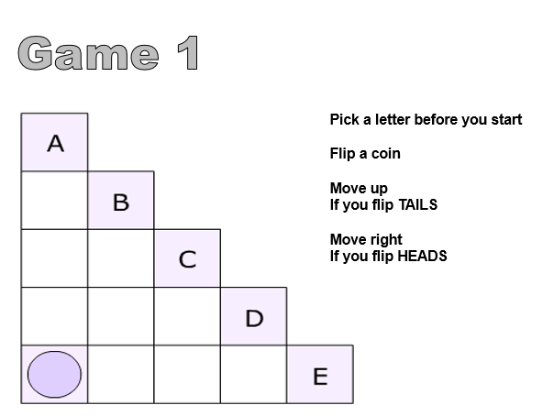

Area/Perimeter
I really like the Nrich problems involving Area/Perimeter
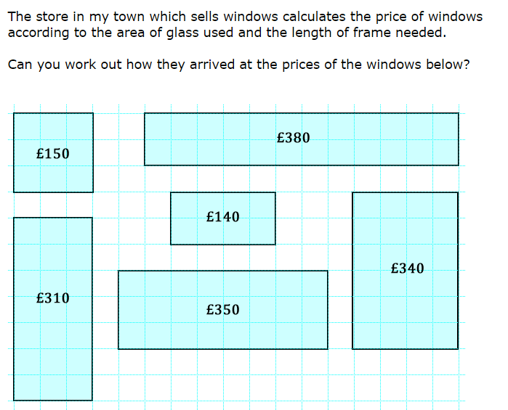
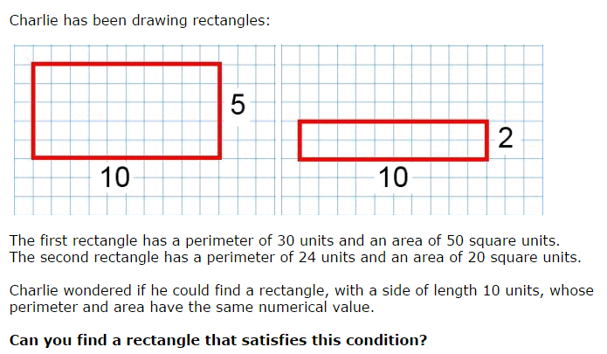
A friend who writes Maths problems that are often published sent the problem below to me. It’s quite nice because you can discuss any misconceptions/errors students make.
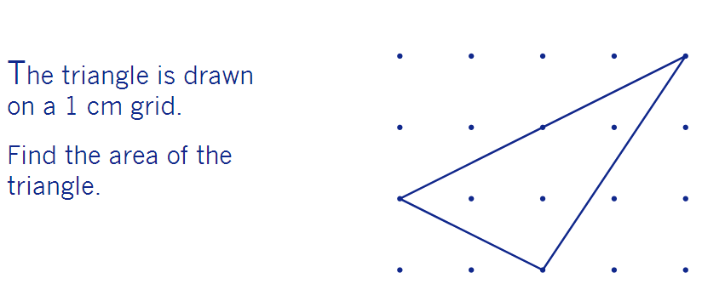
Issue 21
This weekly/fortnightly Maths Newsletter will hopefully give you some ideas for your teaching

Welcome to the 21st edition of a Slice of Pi. This week’s newsletter focuses on tasks that can be used at the end of term. Particularly for year 9 to extend and enrich their thinking of the 2D Geometry and probability
A Slice of Pi

