
https://nrich.maths.org/7812
Maths Shell Problems with Patterns and Numbers
www.mathshell.com/publications/tss/ppn/ppn_teacher.pdf
This booklet of problems was created to address students lack of problem solving skills. The problems highlight a number of specific strategies to help problem solving.
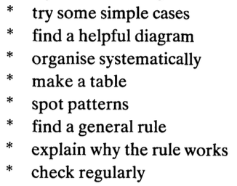
Here are a few problems you might like to try. There is a lot more information in the booklet that is mentioned below.
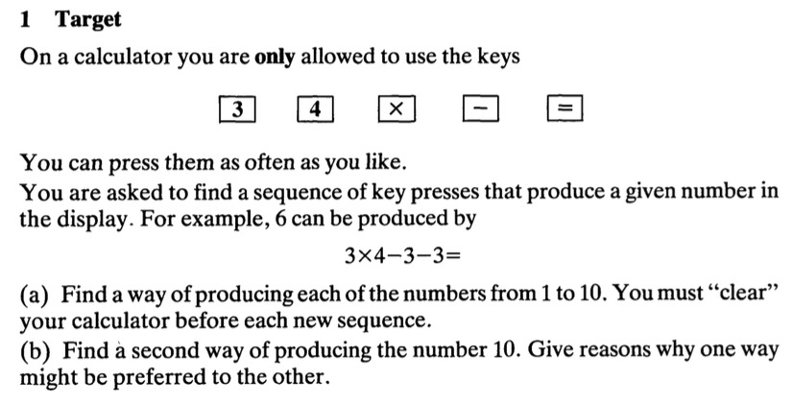
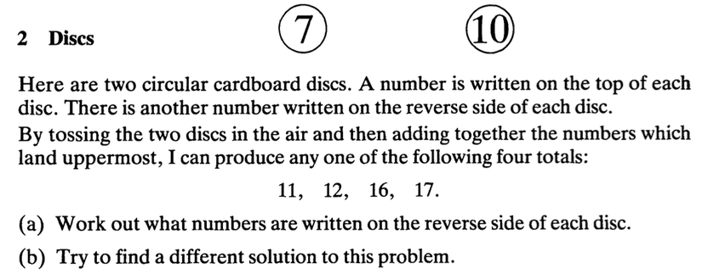
Here’s an interesting article on the nrich site on impriving reasoning.

have

have

Bowland Task How risky is LIFE? ‘My parents won’t let me go out on my own. They think I’ll be mugged, or run over.’
http://www.bowlandmaths.org.uk/materials/projects/download/how_risky_is_life_teacher_guide.pdf
This is a really interesting task for students to work through, it uses probability and statistics to look at how risky life is and odds of actually running into trouble. The resources are fantastic and very useful in explaining ideas with students. This will really engage students too. The data is from 2005 but all accurate and very detailed.
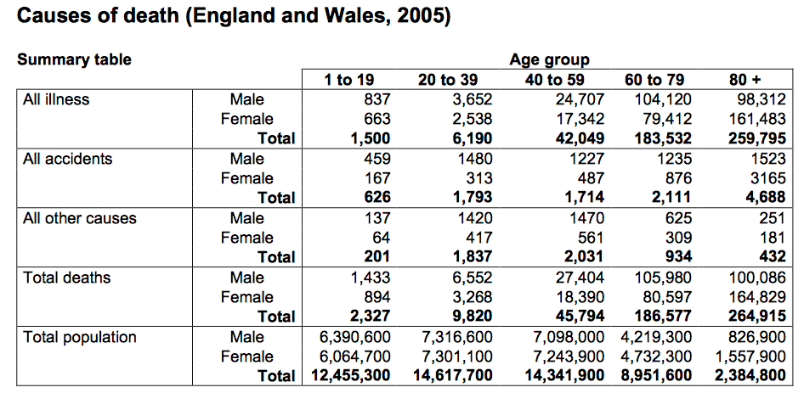
Welcome to the 22nd edition of a Slice of Pi. This week I wanted include some resources and articles by Malcolm Swan. In case you weren’t aware Malcolm died last week after a battle with an illness. He was and will continue to be a huge name in Maths Education. You will, I am sure seen his work either by looking at the Standards Unit, Bowland Maths Tasks, NRich Tasks and MARS. https://www.ncetm.org.uk/public/files/224/improving_learning_in_mathematicsi.pdf

Standards Unit
Some of the Standards Units have been made into really useful ppts on Craig Bartons site. I have still got my copy of this at home and I know Aman keeps her copy at Lower School and Alf showed me many of these resources in my first year of teaching.
http://mrbartonmaths.com/teachers/rich-tasks/standards-units.html

The solving equations unit would be really good to use with year 10 for lesson 2 this week. There is also an accompanying ppt for this unit at the link above.

have

Issue 22
This weekly/fortnightly Maths Newsletter will hopefully give you some ideas for your teaching

A Slice of Pi

