

have

Relay races
Have attached the photos I took after – and a copy of the excel file for the score board. It’s a slight adaptation to the relay races teachers use in class, where students work in groups on a question, get it checked, before being given another question. Put students in groups of 3
- There is one student that will be the runner – they are the only one that is allowed to get out of their seat to get the table checked during the activity
- Give students a copy of all the questions (two per page, double sided, small but still legible font etc.)
- Each team gets a blank answer table (I laminated it, so it could be reused)
- Assign a letter to each team
- Put the score board up, so everyone can see: they get 6 points if answered correctly on the first attempt, 4points for 2nd attempt, and 2 points for the third attempt. After that they need to move onto another question.
- ‘winning’ is not necessarily the team with the highest score, but could be the team that gets the longest consecutive rows of 6s
Linear Sequence Search
I made this worksheet to practice generating linear sequences. Students enjoyed trying to find all the sequences. I have attached the sheet with the email.
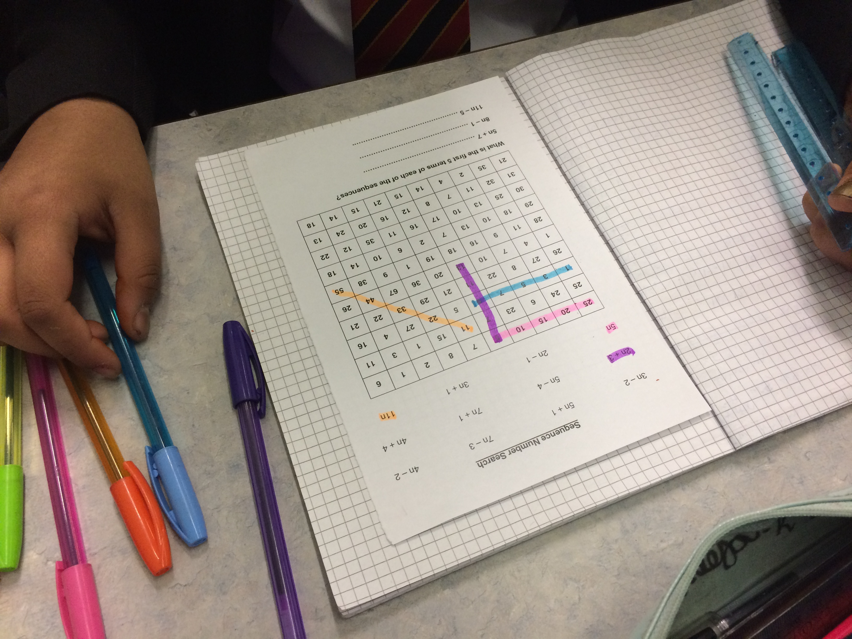

have

Linear Sequence Problem
This is a really nice problem to use with a class to not only practice generating sequences (Linear) but also finding the nth term and it also creates a really interesting result.
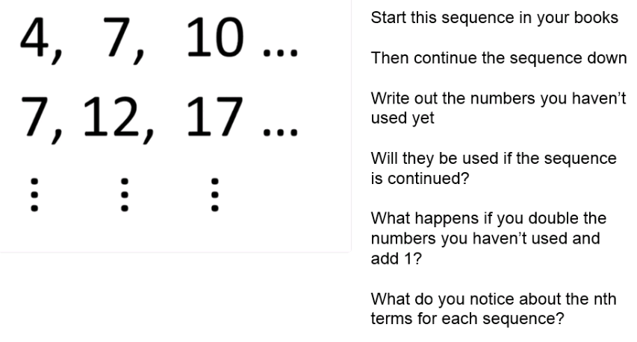
Students noticed the sequences increased by 3, then 5, then 7 etc. They noticed the nth terms were; 3n+1, 5n+2, 7n+3 etc. and then when they looked at the numbers not used in the sequence; 1, 2, 3, 5, 6, 8, 9, 11, 14 and they doubled and added one they got 3, 5, 7, 11, 13, 17, 19, 23, 29….
They then noticed this was the sequence of primes numbers.
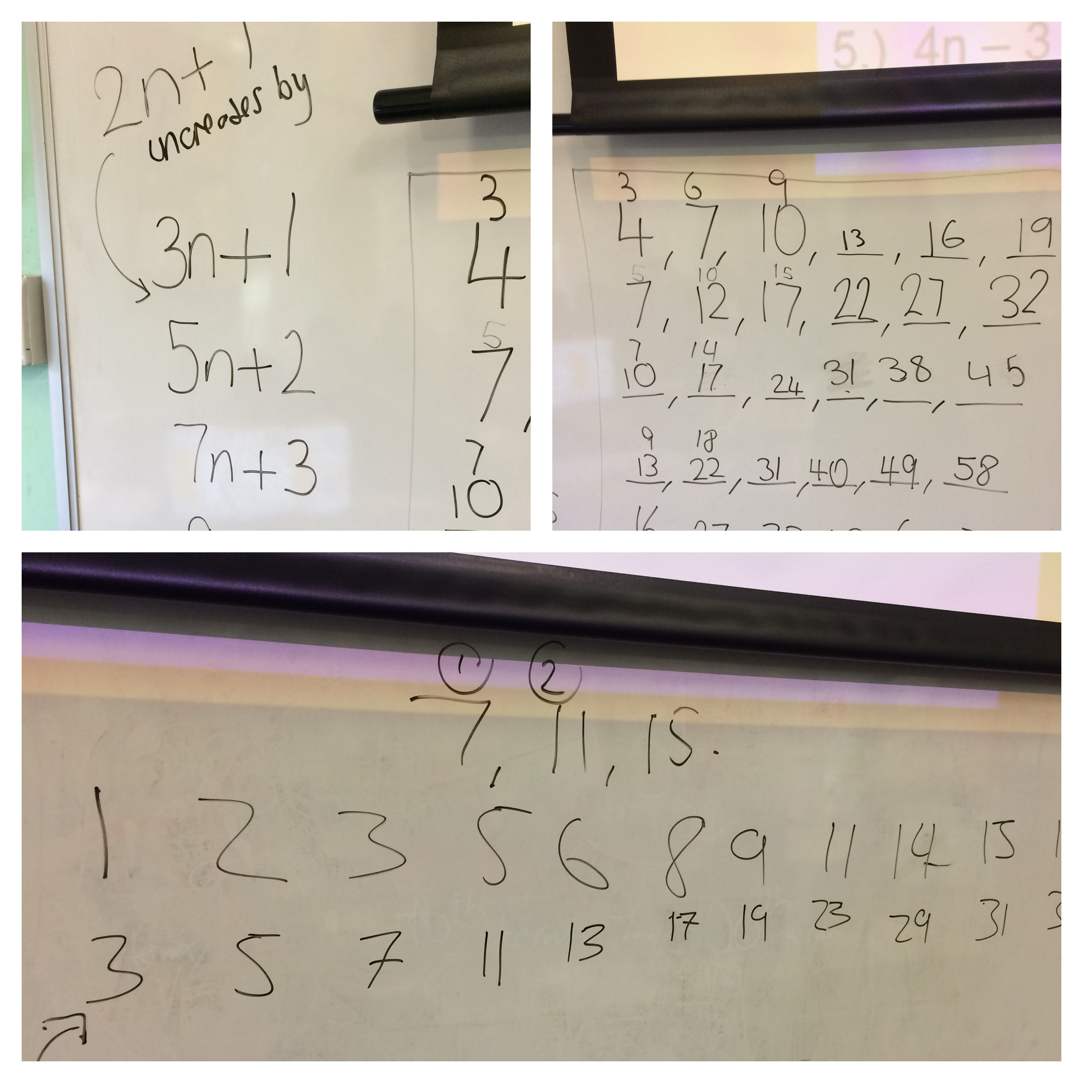

have

Welcome to the 23rd edition of a Slice of Pi. If you’re at Lower you’ll know Sequences is a topic being taught at the moment and if you’re at upper you may not be aware that Sequences will be a topic that will come up once we’ve spent time reviewing the Mocks properly. My thanks to Sana for sharing her experiences with a resource she used with year 11.

Issue 23
This weekly/fortnightly Maths Newsletter will hopefully give you some ideas for your teaching

A Slice of Pi

