
Lesson Study (the premise)
There is now a lot of information about a lesson study on the internet but the basic premise is that a Lesson Study is a Japanese model of teacher-led research in which a triad of teachers work together to target an identified area for development in their students' learning.
A group of usually 3 teachers meet to plan a lesson on a particular topic, which can be selected for a multitude of reasons such as ‘students struggle with this concept’
The teacher can meet several times to discuss and plan the lesson together.
One teacher delivers the lesson and the other two teachers observe.
All three teaches meet to discuss what they noticed and what happened in the lesson and talk about the learning that took place.
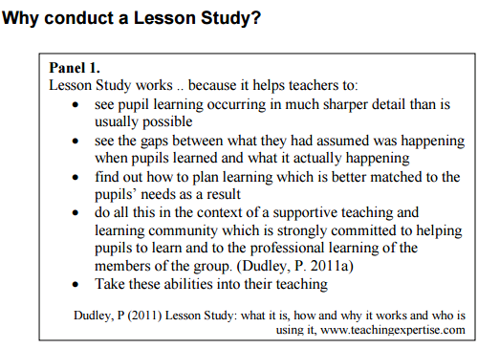
In our first meeting, Kanwal suggested that we should plan a lesson looking at scale factors involving area and volume as she felt this was a topic the students would struggle with.

have

Reviewing the lesson
The lesson went really smoothly because a lot of the perceived issues were thought through beforehand. Students very quickly progressed to finding missing sides, areas, volumes of more complex problems. It was interesting that many students thought that simply being the same shape meant they were similar so any two rectangles were similar. I witnessed a few students saying that they thought that two shapes were similar because ONE side was a multiple of another without looking at any other sides.
Students did quickly notice a pattern with the scale factor of lengths and areas of the second activity but others were confused why the shape fit into the enlarged shape so many times but the lengths had a small-scale factor.
Students recognised the issues with the more challenging questions and had good methods for overcoming them
Scale Factor
Attached to this email is the plan that Kanwal wrote up from our discussions. We decided that students needed to be clear on what Similar Shapes were and to understand that the scale factor for length of a shape is squared for area and cubed for volume. We came up with two worksheets for the starter that teased out any misconceptions students might have.
We decided on good examples and questions that we could ask the class verbally or in a worksheet.
We decided that the worksheet should have all the answers displayed on the screen so that the students could assess the work and alert Kanwal if they were having difficulties.

have

have

Welcome to the 24th edition of a Slice of Pi. This week’s focus is the ‘lesson study’ which I have been involved with on several occasions as part of the planning team, observer or teacher. Last Monday, Kanwal, Justin and I planned a lesson for one of Kanwals year 10 groups, which she delivered and we observed. We then met after to discuss what we observed in the lesson and how our plan went.

Issue 24
This weekly/fortnightly Maths Newsletter will hopefully give you some ideas for your teaching

A Slice of Pi

