
Transformation
Below are some activities I have made or found that get students thinking about the effects of either translation/rotation or reflection. Its useful to have this in mind when applying a transformation because the more ways students can check their answer the better. It also means have a stepping stone to looking at the effects of co-ordinates on graphs that have been transformed.
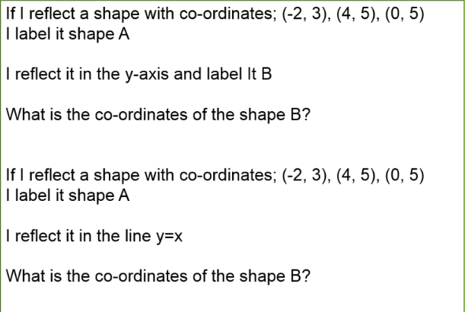
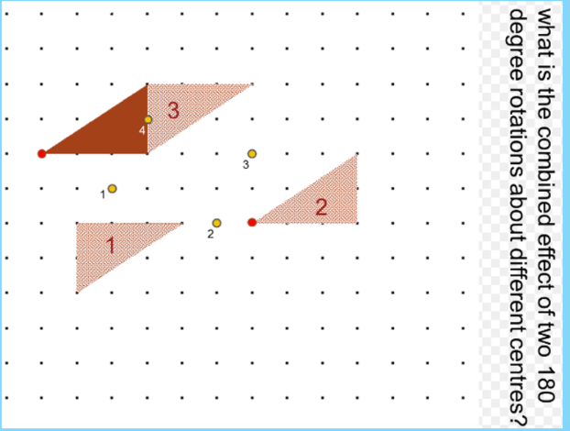
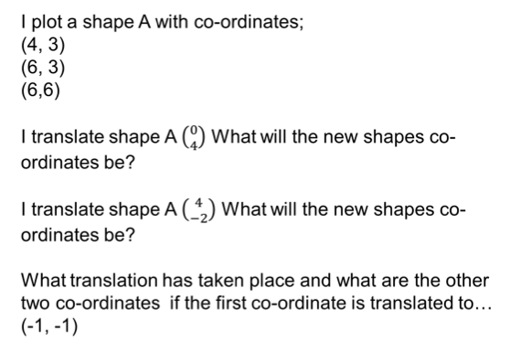

have

Scale Factor/Enlargement
This is a variation of something I mentioned in the last newsletter. It’s a great starter for teaching scale factor involving area and volume or for a plenary when teaching enlargement.
It’s a good activity because students can visually see that the shapes fit into the enlarged shape 4 times but the lengths are only twice as big. You can add more shapes or if extend the task to make it an investigation and allow students to enlarge the shapes by different scale factors and see how many times the shape fits in. Ask the students to find out how many times bigger you need the lengths if you want the shape to fit in 100 times.
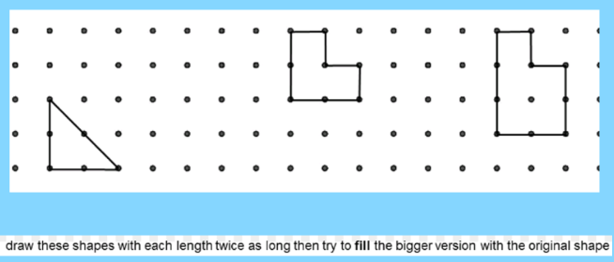
I like to get students to think about the effect of enlargement on the co-ordinates and not just draw them out each time. This activity I created, that could be an extension task or a paired piece, get students thinking about how point B is changed by the SF or C of E. Lots of ideas/generalisations could be shared
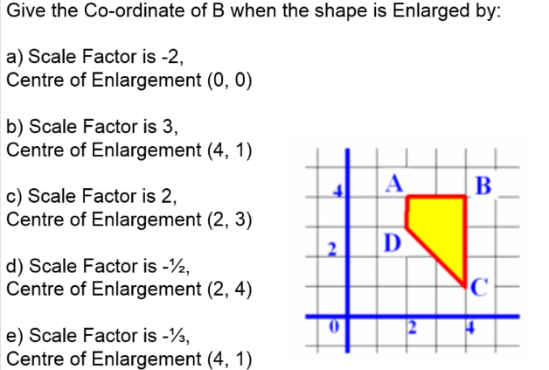

have

Welcome to the 25th edition of a Slice of Pi. This week’s focus is on Transformations. This is being taught at KS3 at the moment and has been a focus at KS4 at different times so is always good for revision. I didn’t send out a newsletter last week because I’ve been busy working with the borough advisor on a lesson study that is taking place on the 21st June period 2. Please let me know if you would like to attend.

Issue 25
This weekly/fortnightly Maths Newsletter will hopefully give you some ideas for your teaching

A Slice of Pi

