Which is bigger? (ICCAMS lesson 9A – revisit)
On Wednesday 21st June I delivered a lesson taken from ICCAMs revisit lessons 9A. This lesson was co-planned with Matt Lewis over a period of around 5-6 hours. We were trying to answer the following research questions
- How do students choose and justify a particular approach to answer a question involving comparing fractions?
- What different conceptions of fractions do students access when working with different tasks?
The full lesson plan and background to the lesson is attached.
After a few minutes spent reassuring the class that they should try to act as if the lesson was any other Maths lesson and to continue to share their ideas with each other and myself, I introduced the first question; ‘which is bigger ½ or 4/9?’.
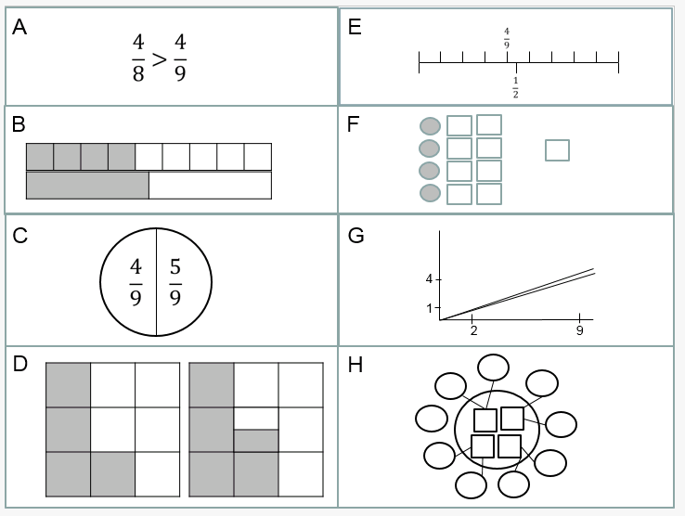
Students were given time to discuss in pairs their thoughts and I said I wanted to see a variety of methods in finding the answer. I walked around a looked at what they had written. All but one of the 31 students had written 9/18 and 8/18, many had used equivalent decimals and a few percentages. There was an attempt on finding diagrams that could show which was bigger and a couple of students had equated 4.5/9 to ½. This was vastly different to my experiences with a set 4 class in the previous week where everyone had attempted a diagram and one student had tried to find a common denominator. I allowed students time to share their ideas but I was satisfied that my predictions were correct and had answered pretty much how I expected them to.

In the second part of the lesson I gave out the resource above that MLE and I put together to hopefully give students an opportunity to see some other ways of viewing fractions. Students were given the chance to share what they thought was happening in each diagram and how it related to ½ and 4/9. I walked around and listened to what students were saying and which were causing particular issues. It seemed C, F, H were problematic, and many converted A into common denominators and were not able to explain why 4/8 was bigger merely by looking at the fractions as they stood. This sheet had too many ideas on and so it took too long for students to properly discuss all 8 and to make sense of them. Some of the connections that were made were that F and H could be related and C and E could be related.
One student drew a circle round the 4/9 and 5/9 in E and drew a line through the circle at ½. Most students ignored G but some did comment on the fact the line that was steeper was the line that passed 1 and 2. Most students had no problem making sense of B and D.
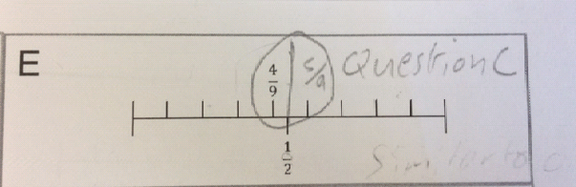

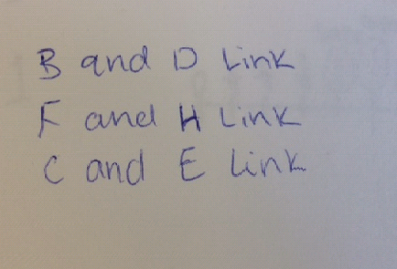
After quite some time had passed I felt I need to move the students on to see if they could apply some of what they had seen on this sheet. I asked for students understanding of H, C, A as I wanted them to discuss as a class the ones they found most challenging. This part of the lesson was hard because the room was large and some students were quieter as they weren’t in their normal surroundings and were conscious of the observers. I wasn’t happy with this part of the lesson because I didn’t anticipate how long it would take the students to work through these and I felt if they had longer they could have made more connections between the methods.

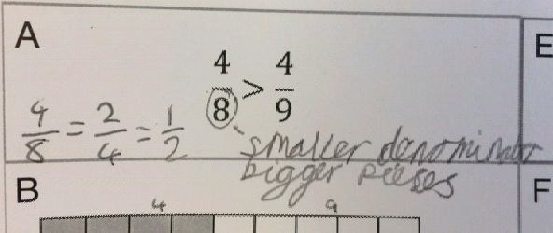
Whilst sharing between the class, students had many good ideas but hadn’t quite made total sense of each idea.

I tried to get students to think of a story to help them make sense of A or F or H and some good stories were shared but I think I rushed this part. If students had been given longer they may have come up with more concrete stories that would have enabled them to better understand A, F and H.
I gave out the sheet with the question ‘which is bigger? 7/8 and 8/9’ and allowed students to attempt this question but asked them to try and be mindful of the sheet they had just looked at. Students did revert back to using common denominator but a few used the hint and looked at how far away the fractions were ftom 1. Those students were able to confidently share their thinking to the class. This was slightly rushed due to the time taken for the second task and I was keen to move students onto the final task. Many more students than in the first task drew diagrams. Some successfully and some were successful but the student was unable to fully make sense of what they had drawn.
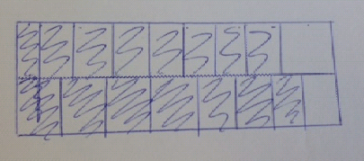
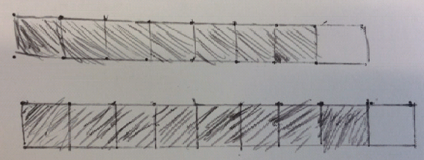

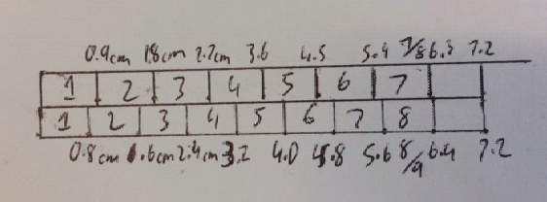
One student used his ruler and 7.2cm as the length of the bar to draw a diagram to compare the fractions. He was able to ensure all parts were drawn accurately this way.

There was some attempt to use the hint ‘which is closer to 1’ below are some examples
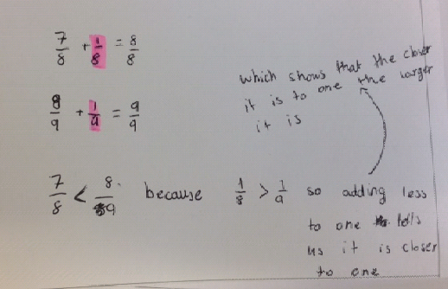
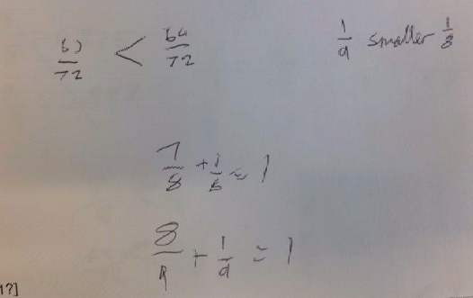

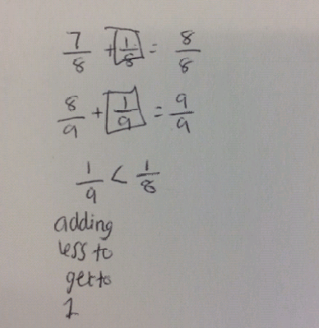

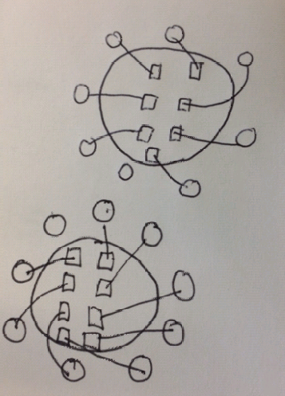
There was also attempts to try and create some of the diagrams from the sheet of ideas the students were given. The problem with this is, many of the diagrams worked because one fraction was ½. Like with the diagrams that were drawn, some students couldn’t make sense of what they had draw or worked out. So they knew 7/8 was 1/8 from 1 and 8/9 was 1/9 away from 1 but didn’t necessarily know which was closer or which was bigger out of 1/8 or 1/9.

The final task was one where students had to find a fraction between 9/10 and 1. I wrote both 9/10 and 1 on the large whiteboard at the front and asked students to come and write a fraction on the board that would lie between the two. Many students came to the front and shared an answer. Time had all but run out in the lesson so I wasn’t able to find out how they obtained the fractions they shared. There were many fractions that had a denominator that was a multiple of 10 and then 11/12, 12/13 was written and a few others where the denominator was one more than the numerator.
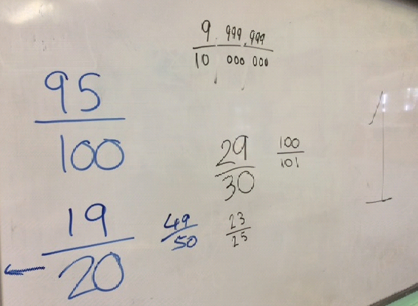
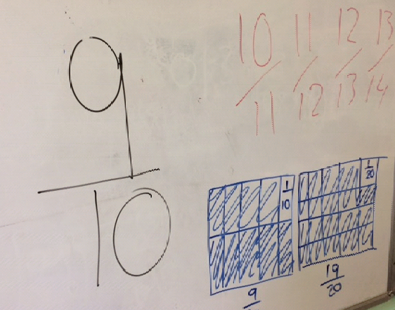
I decided that in the next lesson I should ask the same question: ‘which is bigger 9/10 or 1?’ so we could discuss the answers and how students arrived that their answers. Students had many questions with denominators of 100, 1000 etc like in the previous lesson but there were fractions such as 11/12, 12/13 etc too.
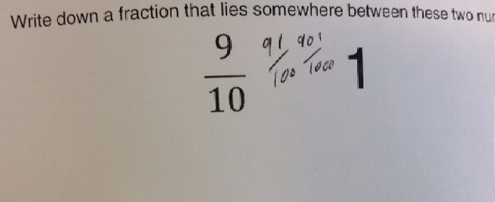
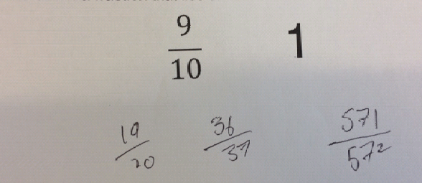
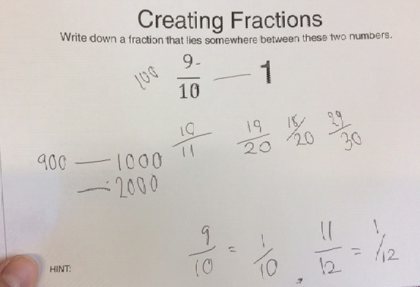
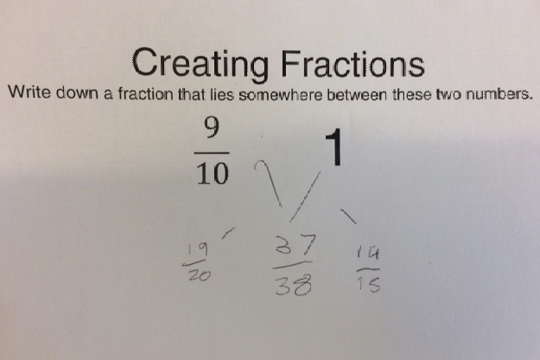
Students mentioned they had used common denominators for some of their fractions but also, they knew 9/10 is 1/0 from 1 and so 11/12 would be 1/12 and 10/11 is 1/11 etc.

I gave the class some time to think of stories where ½ and 4/9 were involved. There was a story about a ship with 2 passengers and 4 ships with 9 passengers and then they struggled with what the question was. One student finally came up with the idea it could be how much space do the passengers ger and in which case do the passengers get more. This lead to a story about a piece of paper with an area of 1m² and another 4m² and they are split equally into 2 and 9 respectively. Which area has the bigger parts? I then wanted to show some stories that I had created that used 1 and 2 and 4 and 9 to see how students made sense of them.

Q1: I buy 2 chocolate bars for £1 in a local shop and the same bars in the supermarket but they are packed as 9 bars for £4. In which place are the bars more expensive?
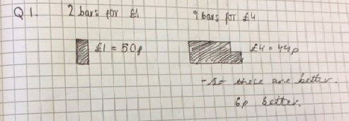
Q2: One rectangle has sides 1cm by 2cm and another has sides 4cm by 9cm. Are the two rectangles similar?
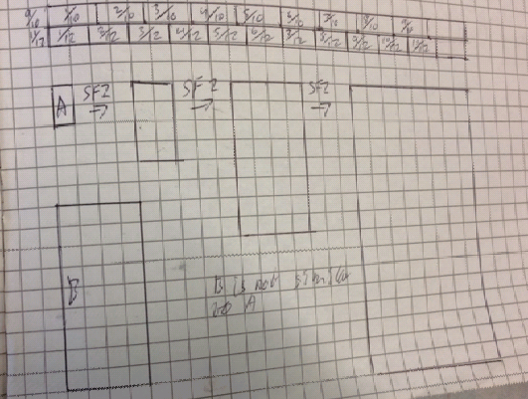
Q3: John walks 1m in 2seconds
Matt walks 4m in 9 seconds. Who is faster?
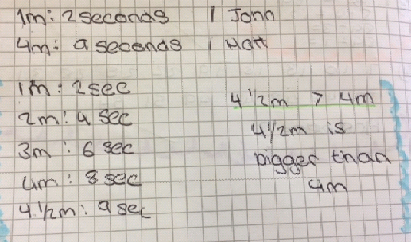
A week later

