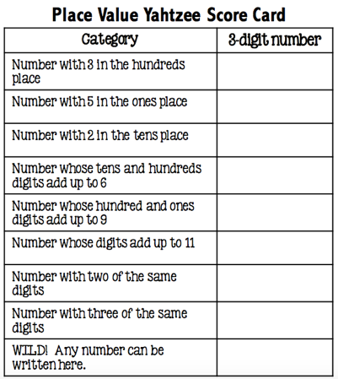

Revision
There are tests coming up in most year groups, year 11 have two in the next few weeks. Thanks to Aman for sharing this website with revision idea;
www.greatmathsteachingideas.com/2010/10/25/maths-general-knowledge-crossword/

The other player also does this with their dice roll. The highest number in each category is the winner. The students really enjoyed the game, there was a lot of peer teaching when errors arose.

Yahtzee
I recently used an excellent resource: Place Value Yahtzee. What was nice about this resource was it was a way of practising a skill but without being monotonous and also getting students to multitask and have fun and be competitive. Students are to roll 3 dice and place an arrangement of the 3 digits into one of the gaps.

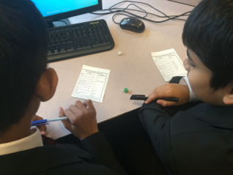

What type of Number is it?
Justins link:
www.numbergossip.com

A Few Problems
Thanks to Justin for sending several Questions to share. I like the one below because not only can students practice their knowledge of what a Prime is, but students also get an opportunity to justify their answers and prove why no other number can fill a space.
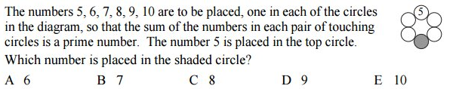
Here’s another nice starter via Justin involving Circles. Sometimes when a problem proves to be challenging discussions in pairs or small groups yields better results than alone or asking the class as a whole.
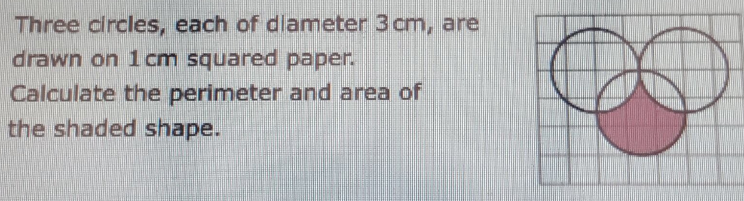

Issue 3
Welcome to the third edition of a Slice of Pi. There have been some great ideas emailed to me this week and I have included as many as I could in this edition and the rest will appear next week. My thanks to Baljit for sharing a ppt task that is attached. It could be an opportunity to remind students of Chess Club that is running at Upper and Lower School. Justin shared a link with me that might be quite interesting to use in class. You can enter ANY number and it will tell you what type of number it is. Website below on the left.

This weekly/fortnightly Maths Newsletter will hopefully give you some ideas for your teaching

A Slice of Pi

