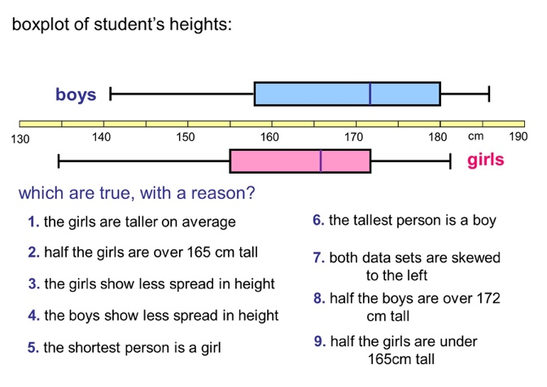
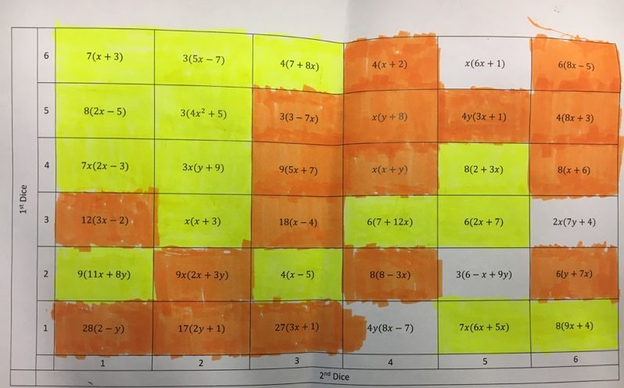

A Video
A video I found that might prompt interesting discussions
https://www.youtube.com/watch?v=BOksW_NabEk&noredirect=1
Take it in turns to roll the dice, find the corresponding square i.e. 4 on the 1st go and 2 on the 2nd go will take you along 4 and up 2. 2.) If it is your turn you must answer the question on the white board by Expanding the bracket. 3.) Your partner can then check your answer
4.) If you get the question correct you colour in the square, this square cannot be used again and if you land on it you roll again. 5.) The player with the most coloured squares on the grid at the end of the game wins.

Expanding Brackets Game
Ahlam shared a game that looks engaging and practises an important skill. Here are the rules:

Worded Graph Problems
I had a conversation recently with Sana about the importance of real life examples in graph because it makes the idea less abstract for students, it helps them make sense of the letters if they can give them meaning and it also make sense of the gradient and y-intercept and reading graphs etc. For example, a graph of y=4x could be related to a taxi charging £4 a mile and y=2x+5 could be a taxi charging £2 a mile but a fixed charge of £5. Sana then kindly emailed me the lesson on Mobile Phones that she made that she based on a Bridging Unit she found. It looks great and she said her class not only enjoyed it but it helped them give meaning to the graphs they were plotting. Attached is the ppt and unit Sana used.
I have used the question…
Which is better?
Swimming Club A who charges a £5 membership and £2 for each visit or Swimming Club B who charges no member fee but £4 a visit?
It’s a nice way to start the graphs topic without using letter notation straight away.

Welcome to the 4th edition of a Slice of Pi. Year 11 have begun assessments and both year 10 and 11 have been looking at Graphs and 3D shapes this half term. Sana has shared a nice lesson that she found which uses real life examples in graphs and Ahlam said she used a starter that was really effective because students were enjoying the competitive element to it. Below is an interesting starter I found involving Box Plots and interpretation. I stumbled across it and made me think of a recent conversation I had about analysing data and if there were any interesting resources on box plots.

Issue 4
This weekly/fortnightly Maths Newsletter will hopefully give you some ideas for your teaching

A Slice of Pi

