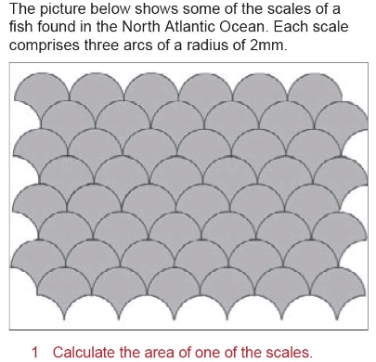
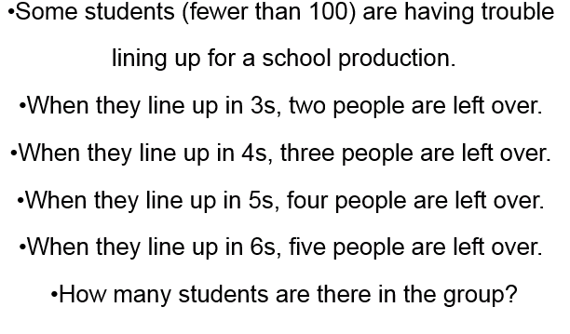

A question on Area of Sectors
Yahtzee (Again!)
A few weeks ago I shared a Yahtzee place value game I found. I adapted it and made one to finish the Types of Number section of work and after students finished the game I posed the following questions:
What Number types did you struggle to fill? Why?
Which number could fill the most boxes?
Did you have a strategy for winning?
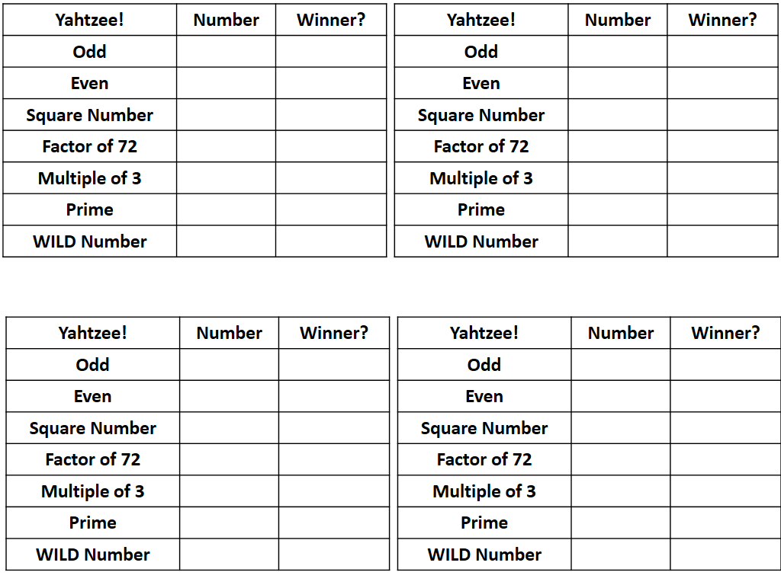
Factors
I used the problem above in my lesson with year 7 top set. They have been in sets for two weeks now and one boy piped up with: we did this problem in Ms Bains lesson. So after allowing time for them to explain their answer of 59. I decided that instead of moving on I would see if they could find more answer that could be bigger than 100. One boy said he thought doubling 59 would work but then the class realised this would result in a remainder of 4 with 3’s lined up and that meant 1 remainder really (4 mod 3 and all that)
Then they found that 119 worked and then 179 next. I won’t bore you with the rest of the lesson but it was quite interesting.

Welcome to the 5th edition of a Slice of Pi. I have been raiding IKEAs ‘free’ stuff again and didn’t just leave with bundles of little pencils but I asked if I could take a stack of the paper measuring tapes because I thought they may prove useful. I was right. Last week one of my classes found the circumference and diameter of circles (paper plates, cups etc) and the flexibility of the paper tapes meant they could easily find the circumference.

A Video: Thanks to Aman for sharing the link below that has great videos that can be used as a talking point for starters
http://www.mathematicshed.com/dr-who-maths-shed.html
Issue 5
This weekly/fortnightly Maths Newsletter will hopefully give you some ideas for your teaching

A Slice of Pi

