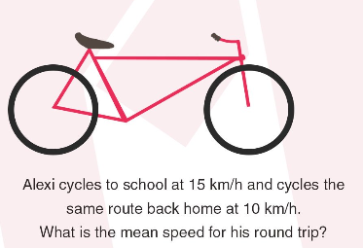
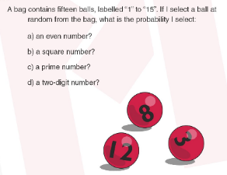
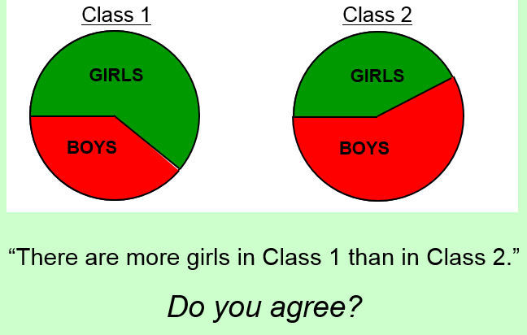

Mean Speed
Tough little problem on Mean and Speed. I get the answer of 12km/h but not sure it’s the easiest method though!
Number Sense
Thanks to Justin for this video which visually shows way to calculate multiplication questions using partition
https://www.youcubed.org/what-is-number-sense/
Data in the UKMT
In a week’s time, some of year 12/13 will sit the Senior UKMT and the question below was a past question:
Have a look at some possible methods to solve it that aren’t the traditional algebraic methods.
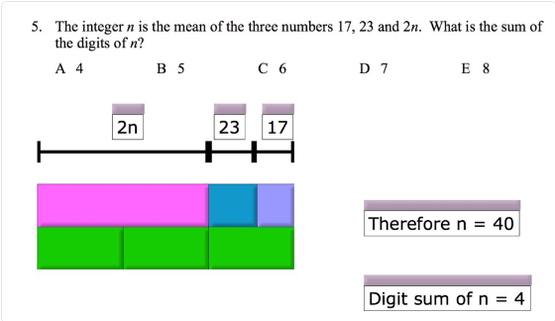
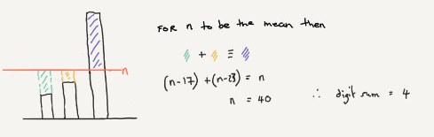

Welcome to the 6th edition of a Slice of Pi. This edition is mostly focussed on Data as this is the topic most of Upper school are working on. It also includes some number work because at Lower school we are working on Number Types and with ICCAMS being used in a few weeks which does look at ideas that are demonstrated in the video link that Justin Shared with me and I’ve included below.

Pie Chart Comparison
It’s an old type of question but I like to use it every year and it does form some good discussions from it.
Issue 6
This weekly/fortnightly Maths Newsletter will hopefully give you some ideas for your teaching

A Slice of Pi

