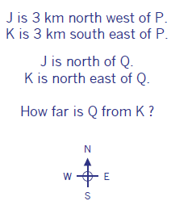
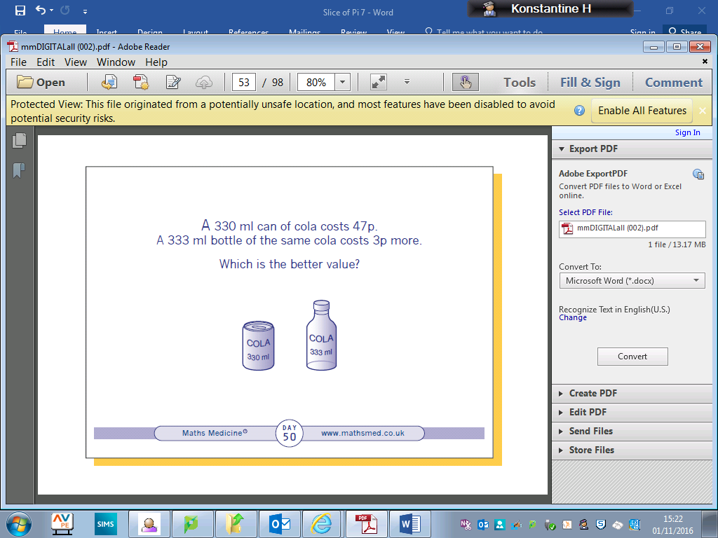
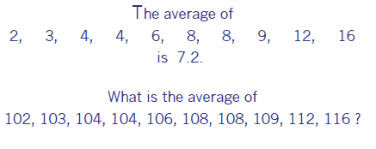
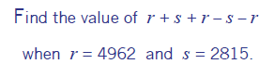

Compass Points

Multiplying Fractions

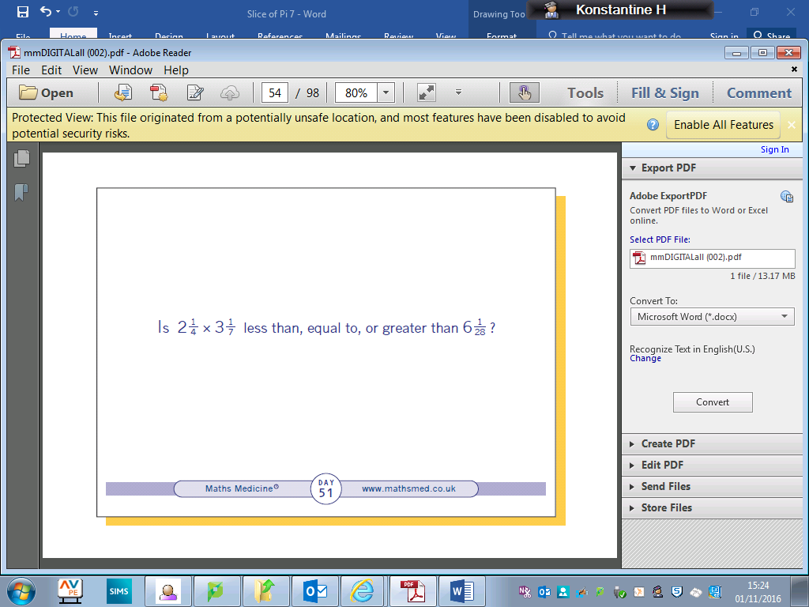

Comparison

Sequences
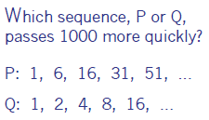

Scatter Diagram for Speed
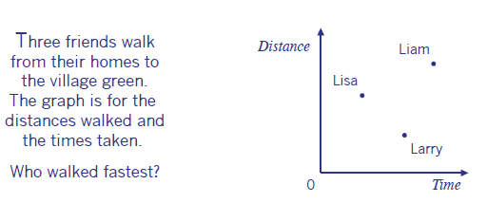

Simplify the Problem
Interpreting tables
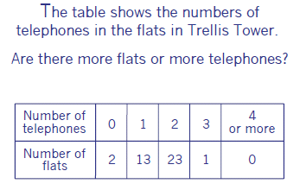

A Mean Problem
Welcome to the 7th edition of a Slice of Pi. Included this week are lots of problems I have found in two books I was kindly given by Professor Smudge. If you are on Twitter you have to follow him @professorsmudge The problems are engaging and are great for discussions and require some logic and common sense too.

Issue 7
This weekly/fortnightly Maths Newsletter will hopefully give you some ideas for your teaching

A Slice of Pi

