Welcome to the 8th edition of a Slice of Pi. The theme this week is fractions, decimals, percentages and ratio. It’s not long until year 11 leave for study leave and the other year groups will be completing their assessments. I’ve spoken to people about how they revise and review tests. Some ideas are included and I have attached another multiple choice sheet if any use.

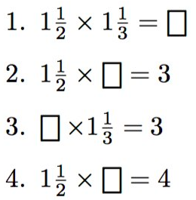
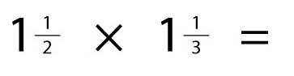

Percentages
I made this with colour codes so students know which are easy and which more challenging, early solutions help harder ones like 111%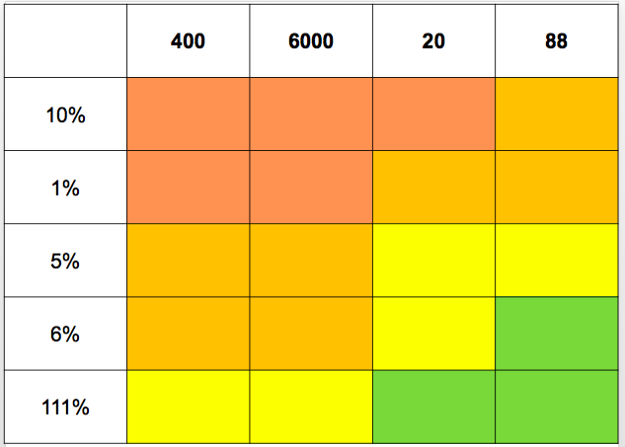

Can the result be used to calculate
Use the result to find the missing gaps

The Decimals Game
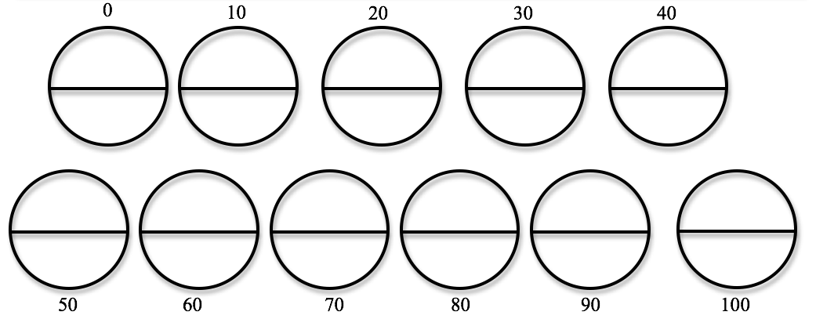
This is from Nrich – Reasoned Rounding game. Students roll 2 10-sided dice and write the number in one of the gaps. When a student fill the second half of a circle they win that circle. EG: roll 3 and 5, so it’s either 53 or 35 and you fill in either 50 or 40. Winner fills the most circles.

A surprising fraction calculation
This calculation has an answer that could be shown with a diagram but how do you show that dividing one fraction with another is the same as ‘flipping the second fraction and changing the divide to a times’
Proportion in Real Life
How much does it cost to park per minute in Wandsworth?
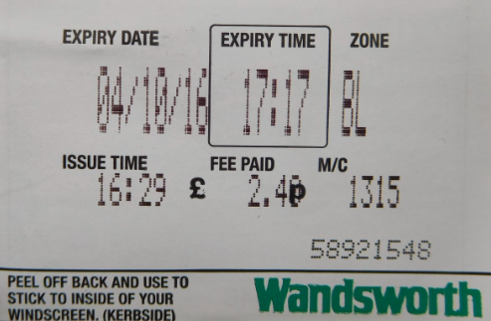

Revision
Ahlam gave each student in her year 11 class a post-it note and asked them to write a topic that they wanted to go over in class before the mocks. This method could be used in any year and gives you an idea of the topics students aren’t confident with.

Issue 8
This weekly/fortnightly Maths Newsletter will hopefully give you some ideas for your teaching

A Slice of Pi

