Probability
Don Stewart has a great collection of resources. For those staff about to teach probability, do check his website out.
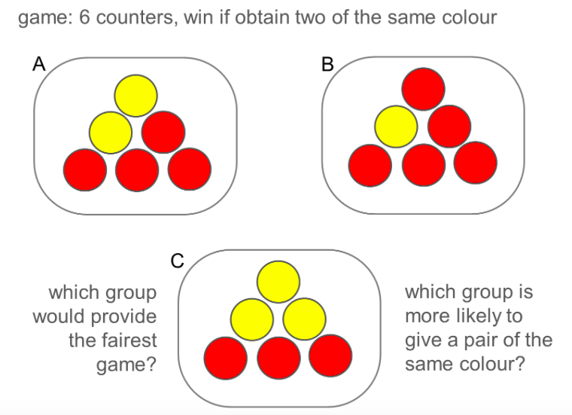
http://donsteward.blogspot.co.uk
his work is based on numbers from:
http://www.squaring.net

Fraction problem
Year 11 looked at this question last week: 24 pens were in a shop, a quarter were red and cost 5p, the rest are blue and cost 3 times as much. There were 2 different methods and I introduced a third and drew each as an image so I could explain why each method was equal. This linked nicely to area of compound shapes
Welcome to the 9th edition of a Slice of Pi. Here a collection of questions I used last week. I like finding interesting questions and hearing how students solve it, then connecting it to other topics so those topics are fresh in the memory and enable students to view problems in more than one way. Now some staff are on study leave maybe youll have a minutes to email any interesting activiites you have used this week

We discussed Factors and why the rectangles stated are the only possible answers. 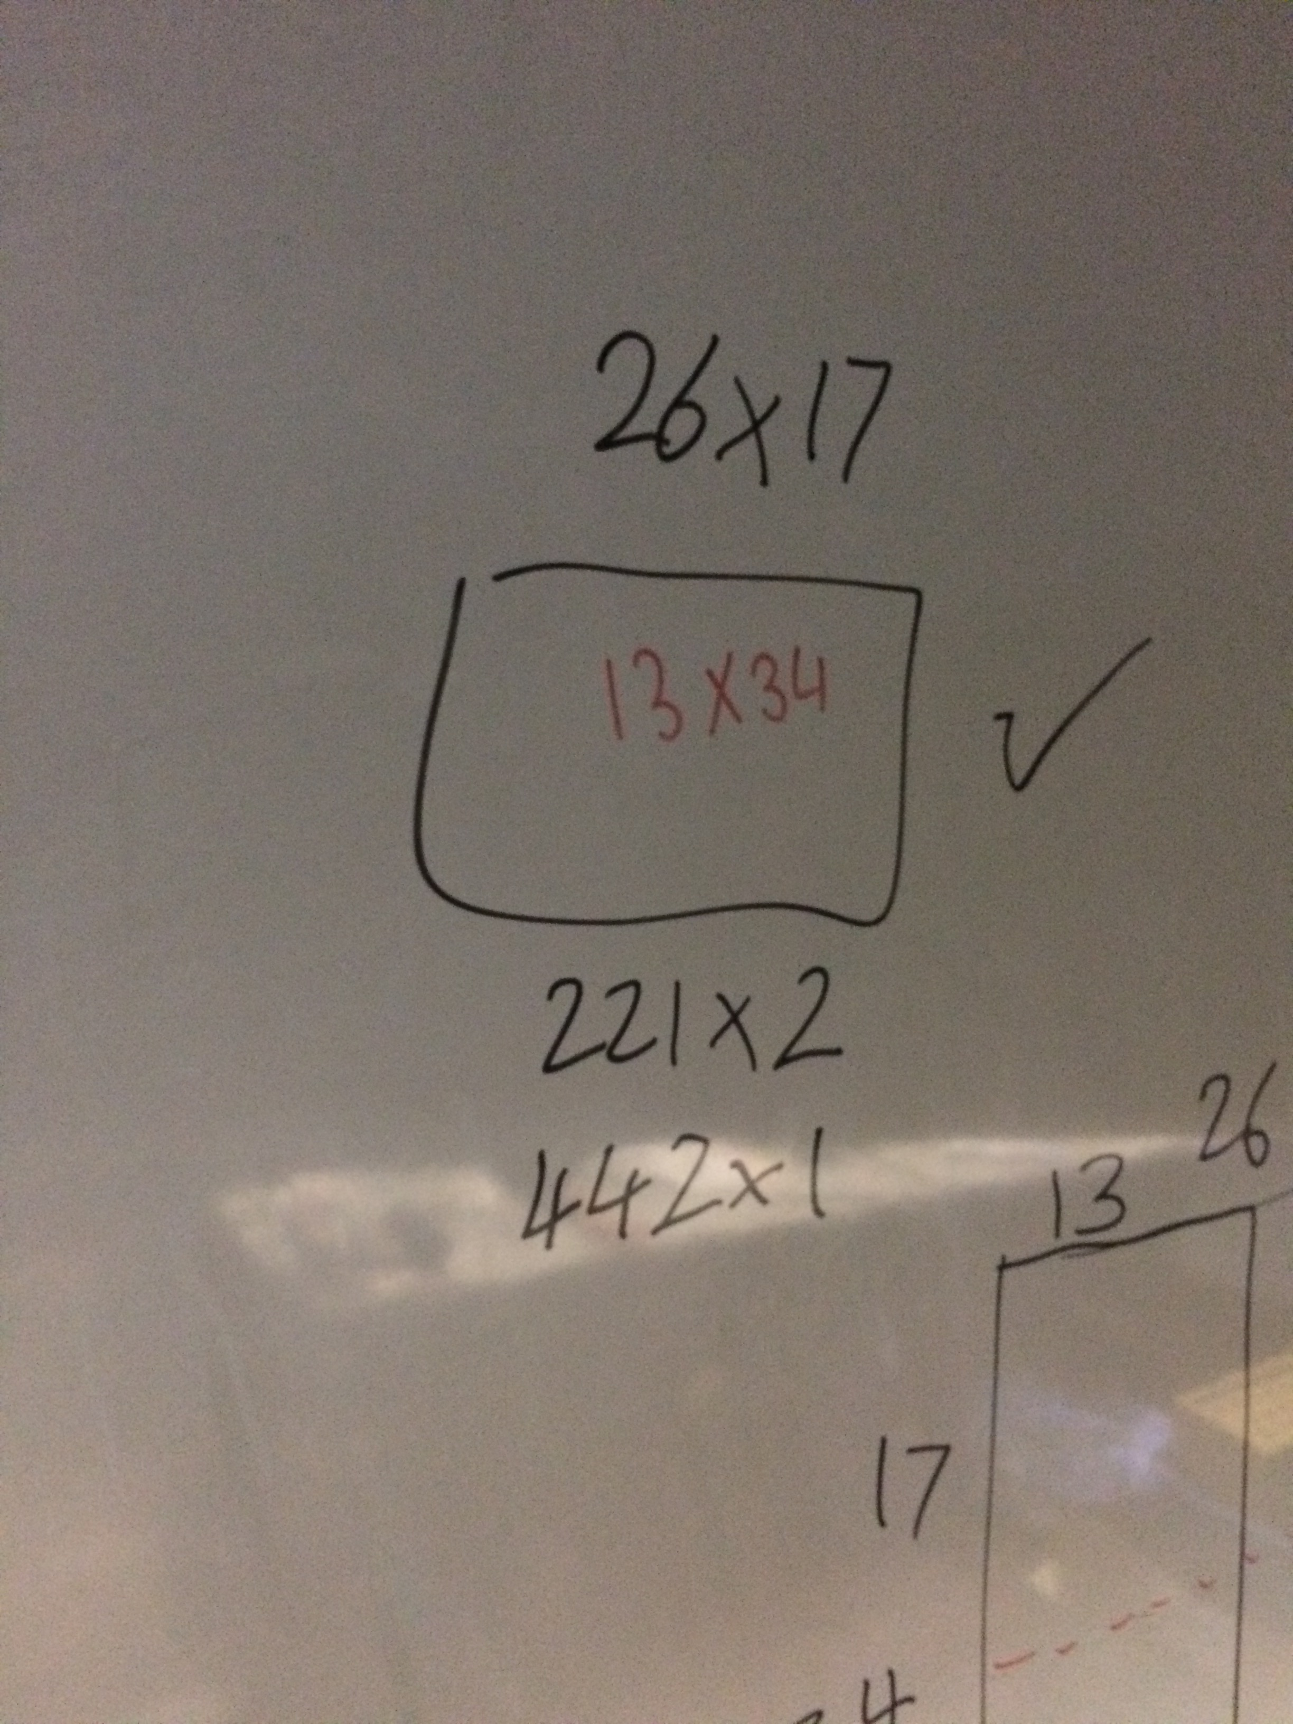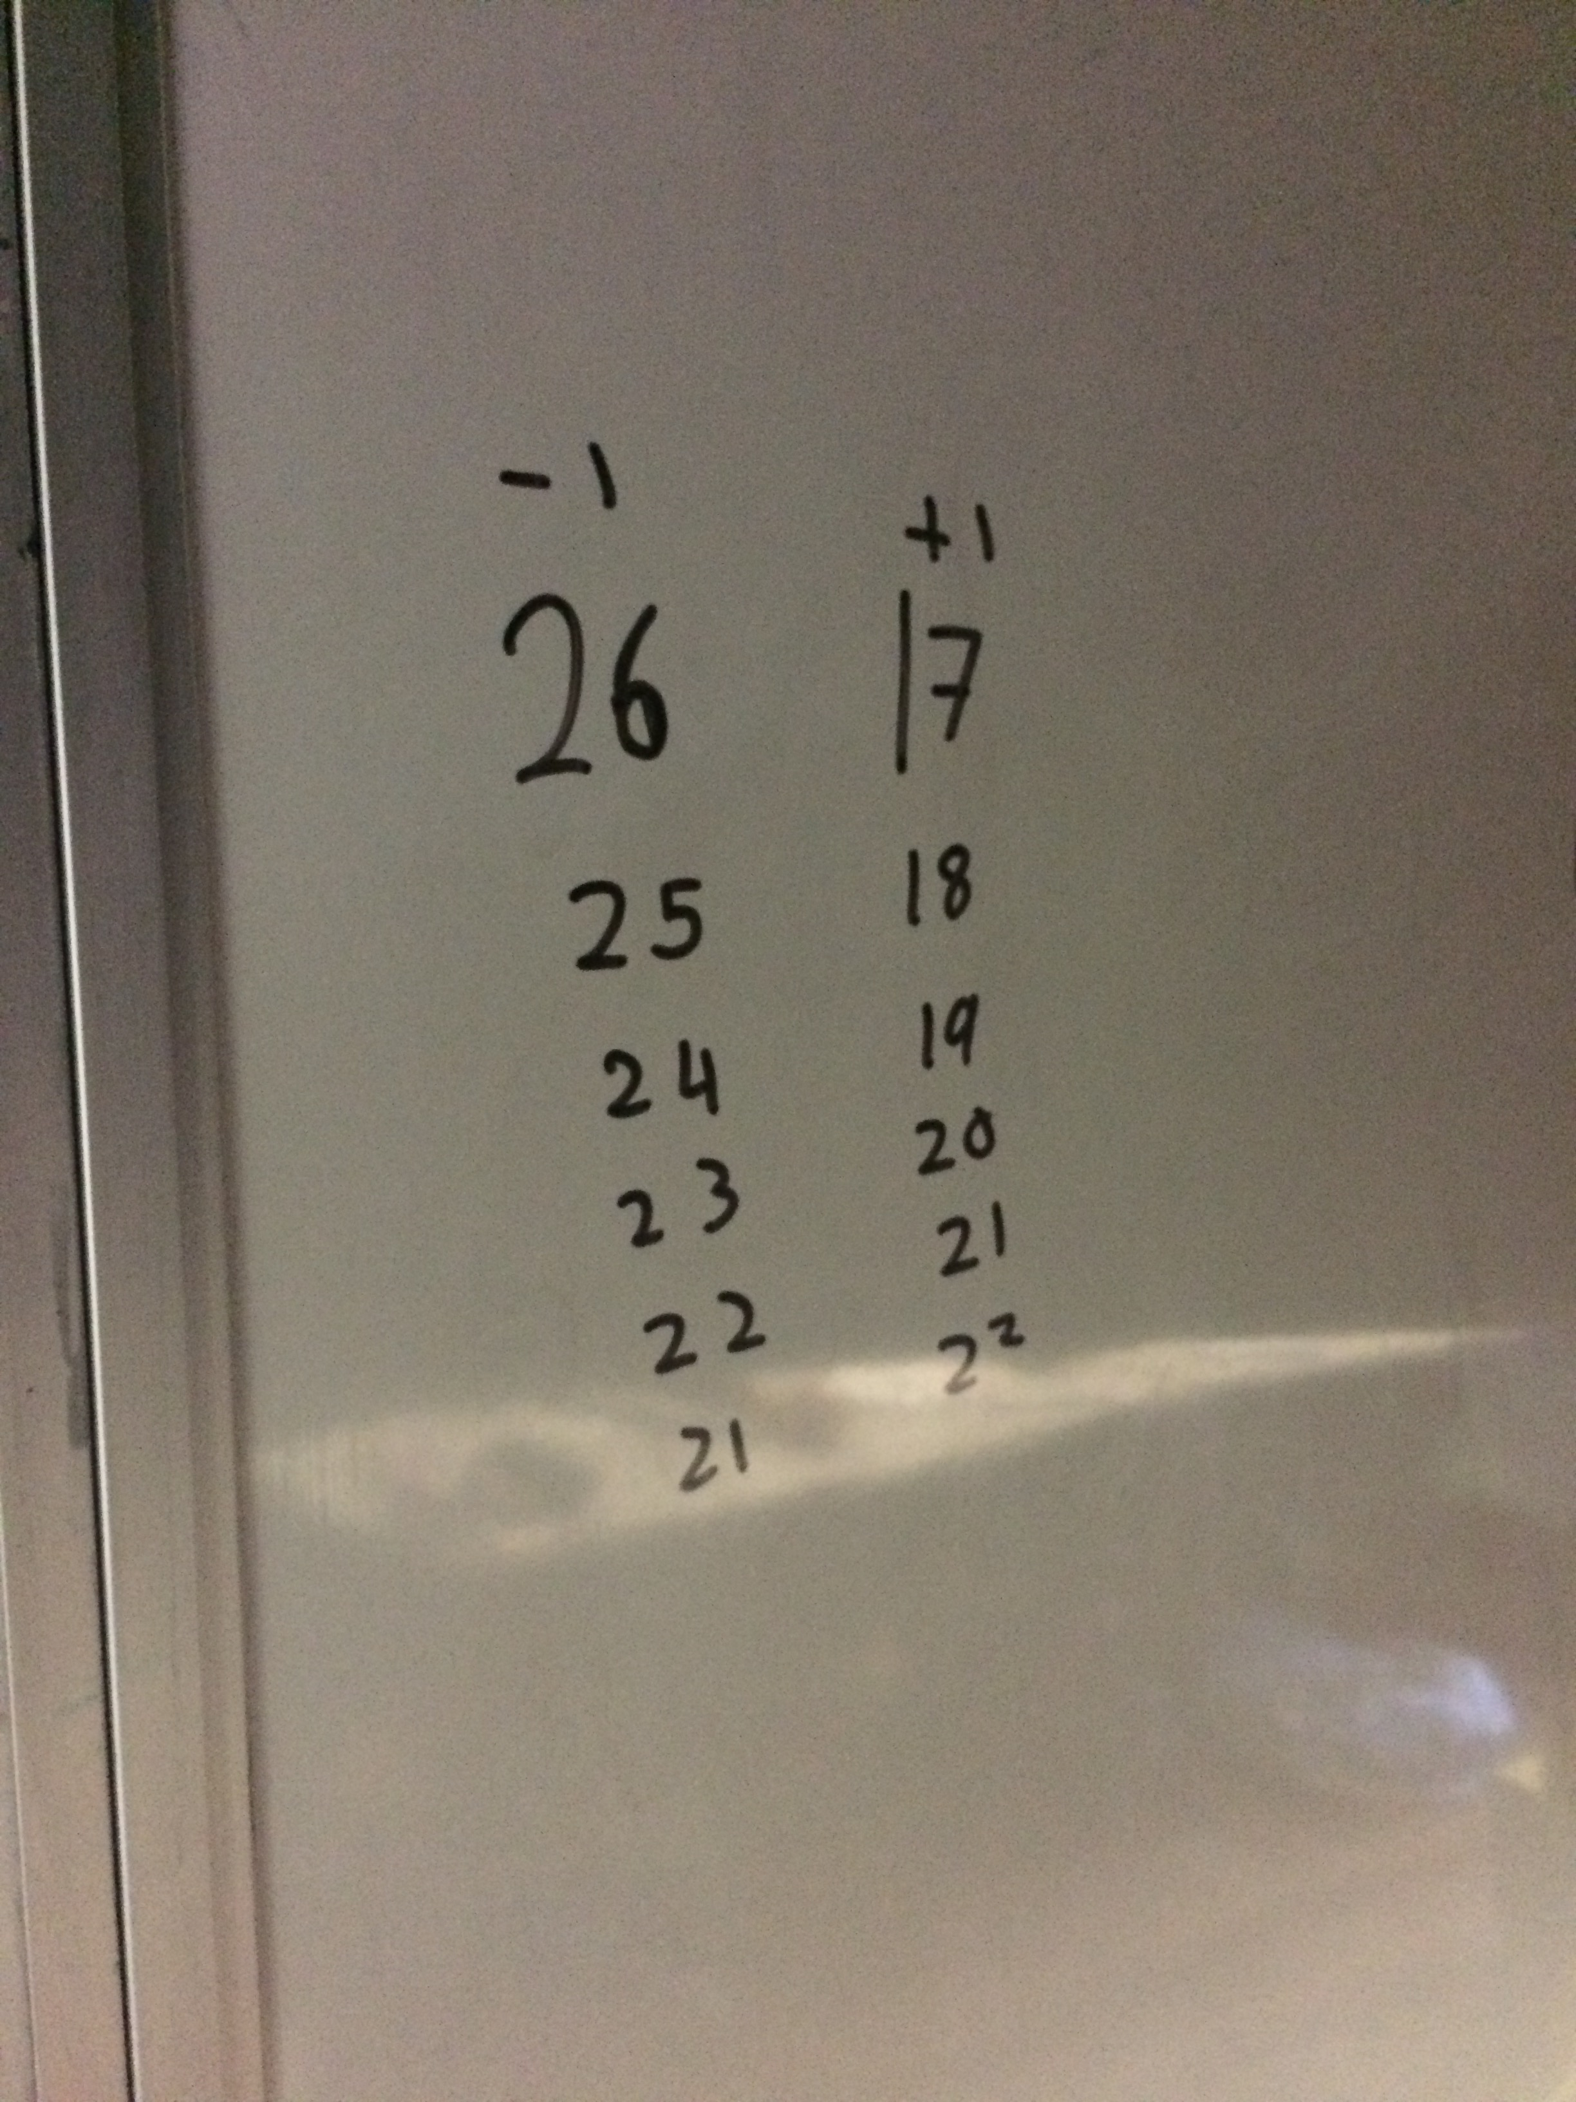
It’s a simple starter from @Professorsmudge but does get students discssing interesting ideas.
Arrays
I used this starter with 7a1 last week. A few responses I got are shown right. I made a gif with an explanation why the top doesn’t work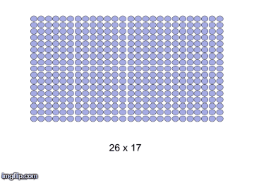

Can the result be used to calculate
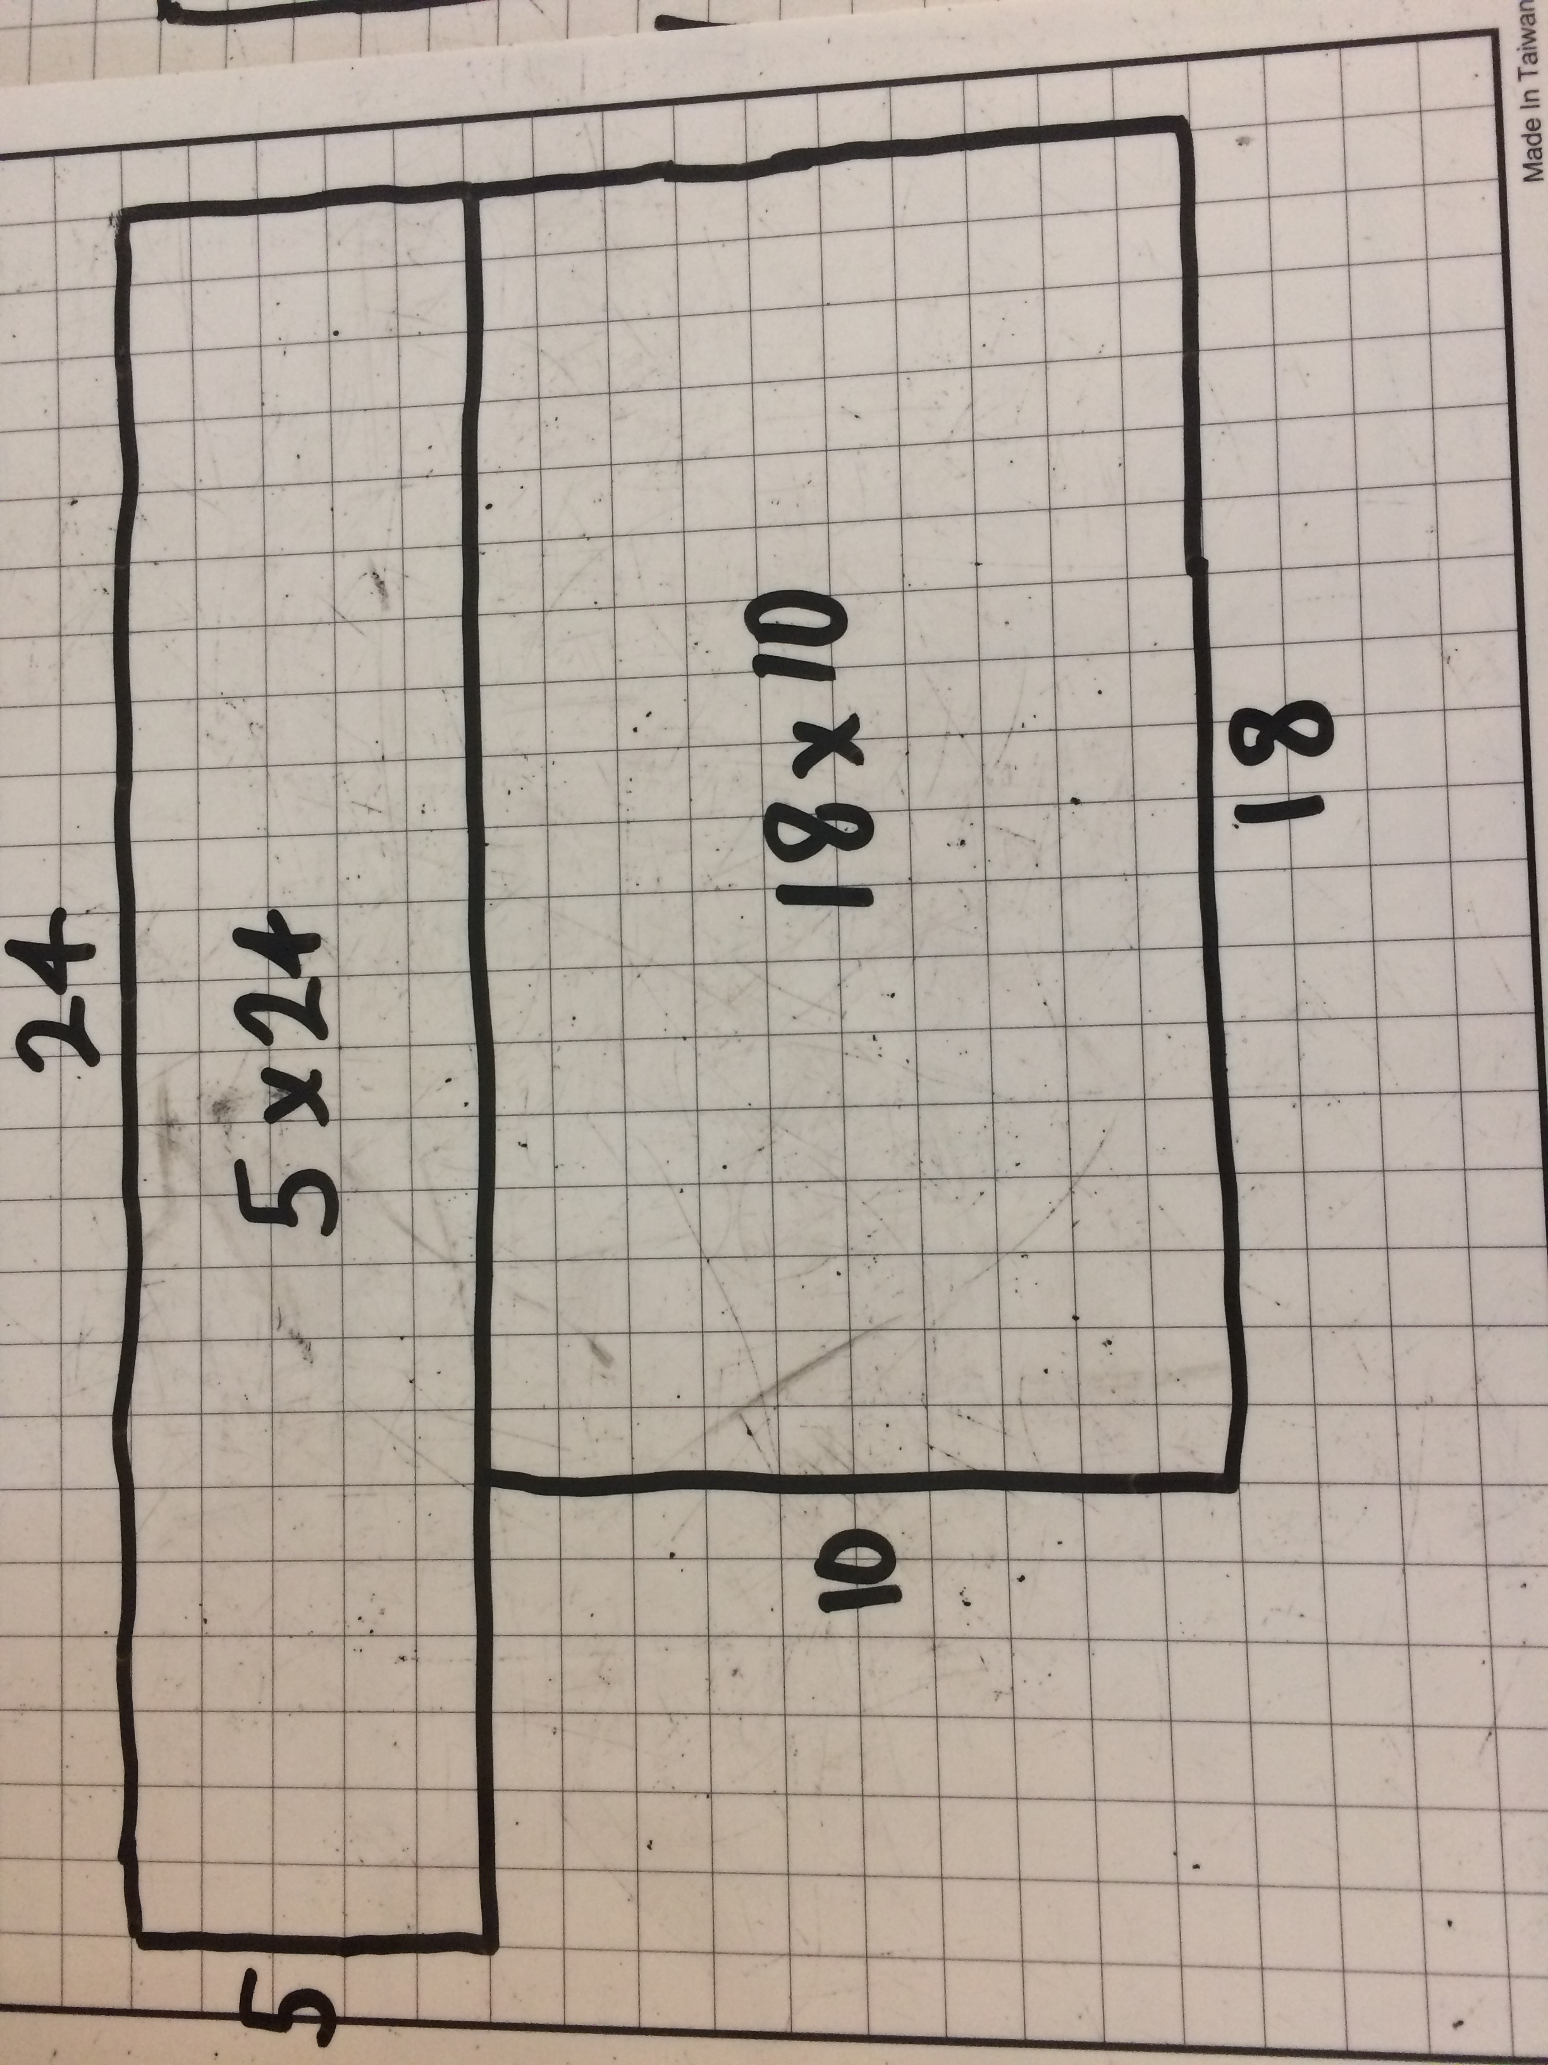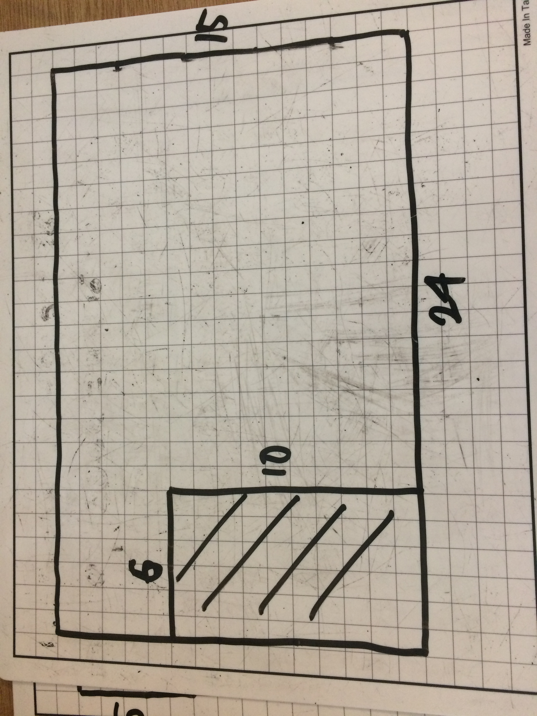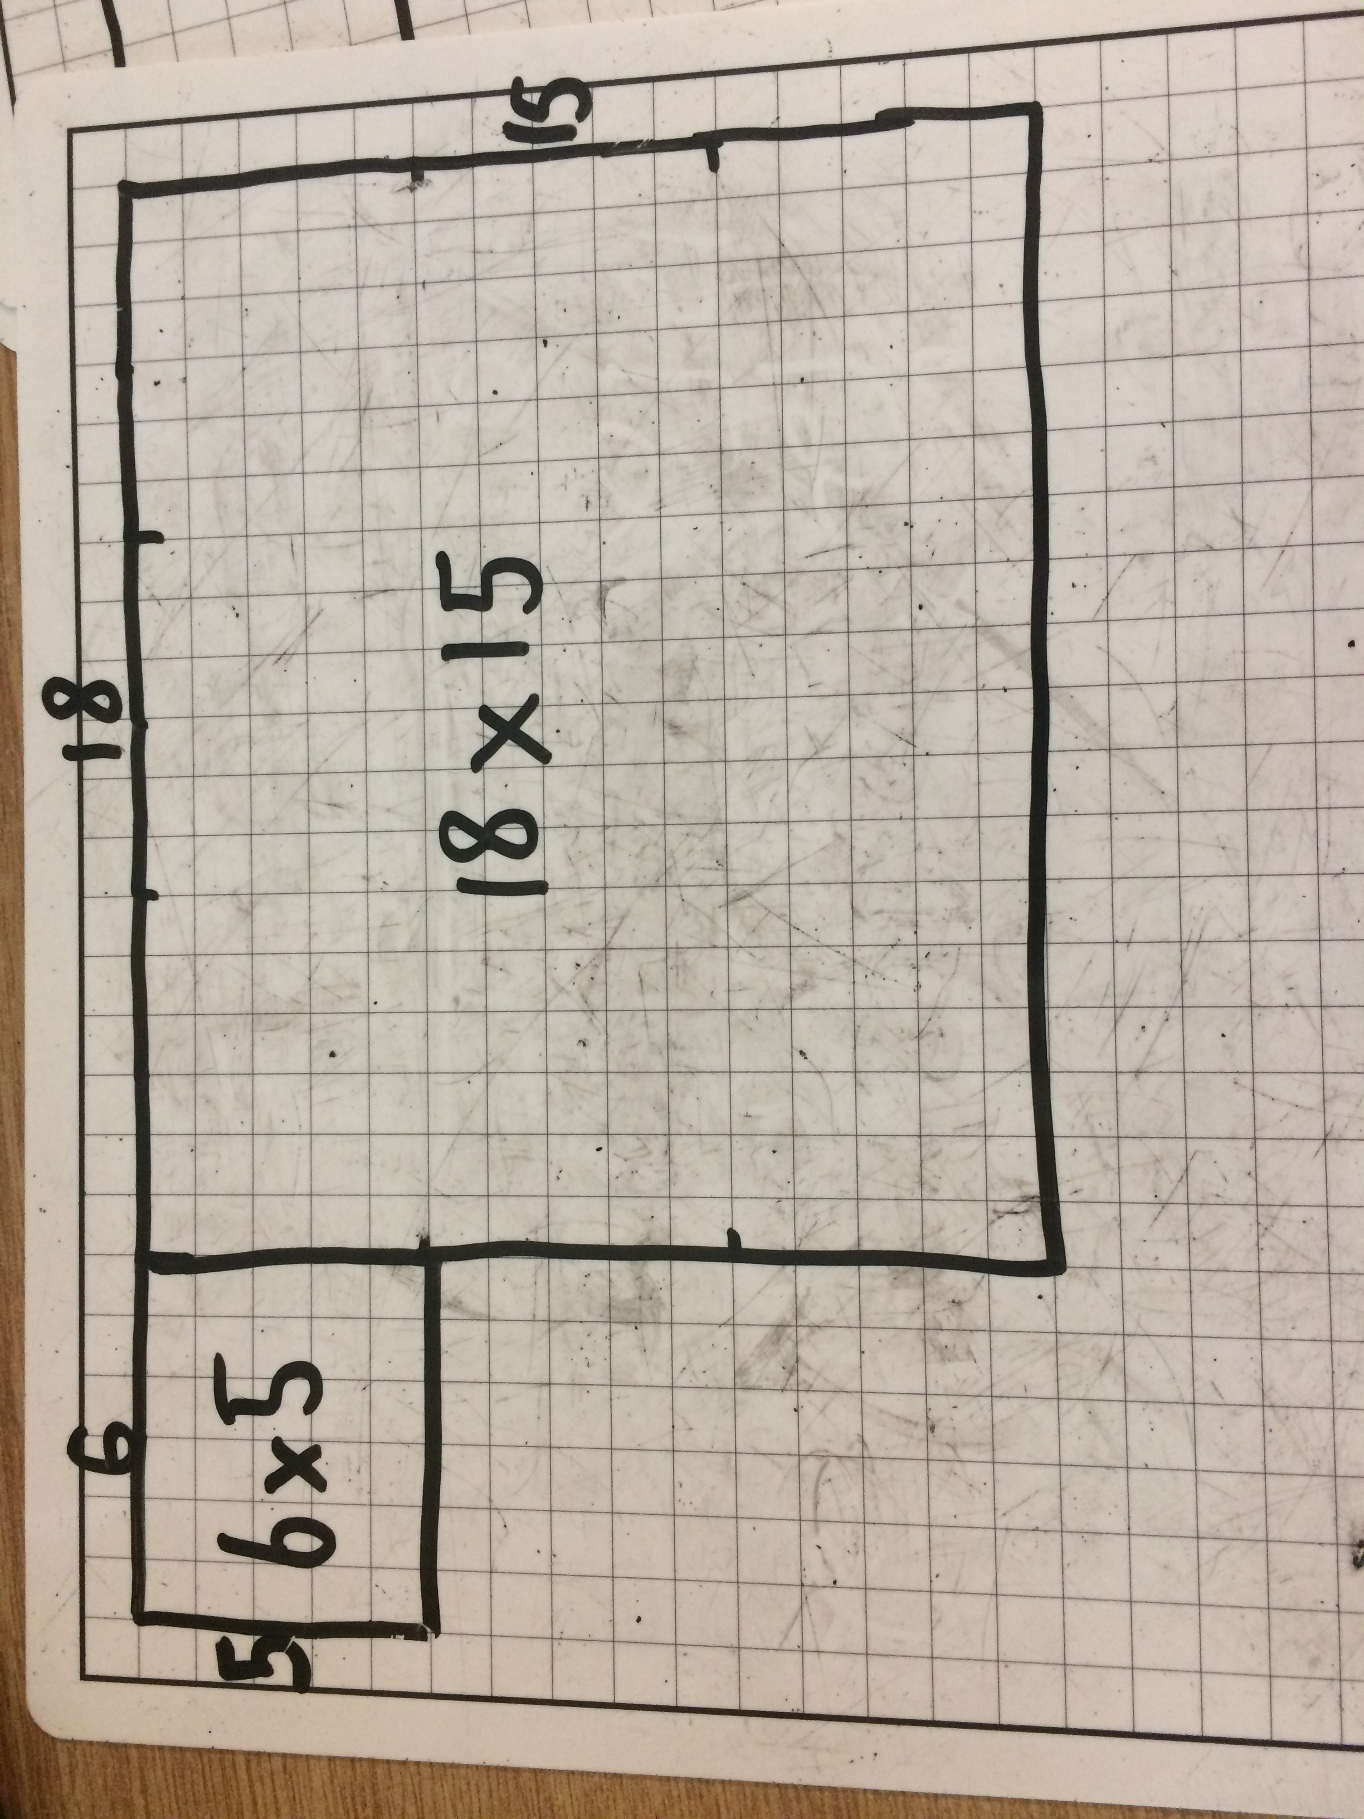
Issue 9
This weekly/fortnightly Maths Newsletter will hopefully give you some ideas for your teaching

A Slice of Pi

