Forms and using a shortcut in chat
In the chat box, click the 3 little dots below and click FORMS | Write Q1 and then “add options” so you have 4 options | Change the options to A, B, C and D
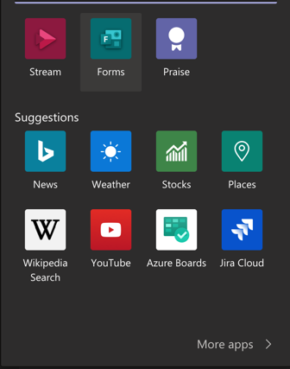 | 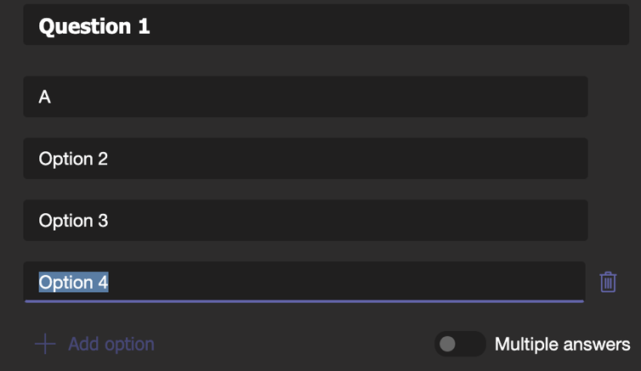 | 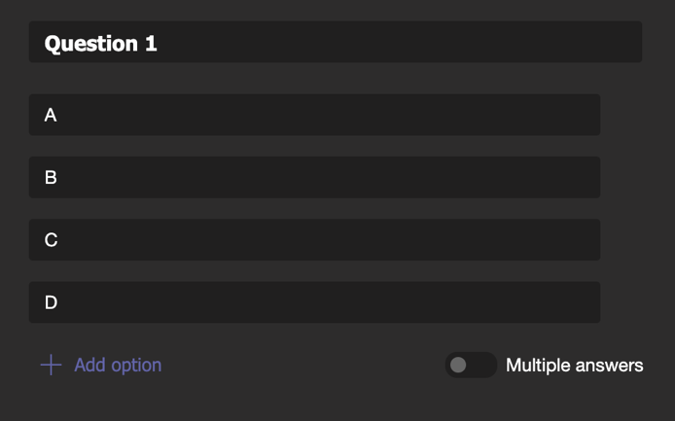
Click “save” and then “send” | After you have done one like this you can short-cut. Type @forms in the chat and select the TOP option “forms” | It will go purple and you can follow it with Q2? A, B, C, D  Repeat
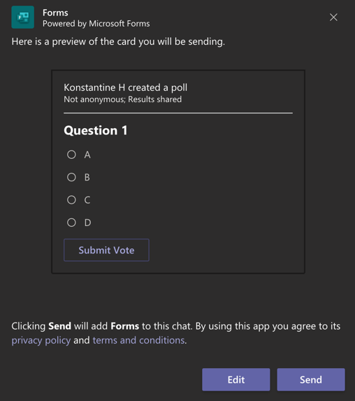 | 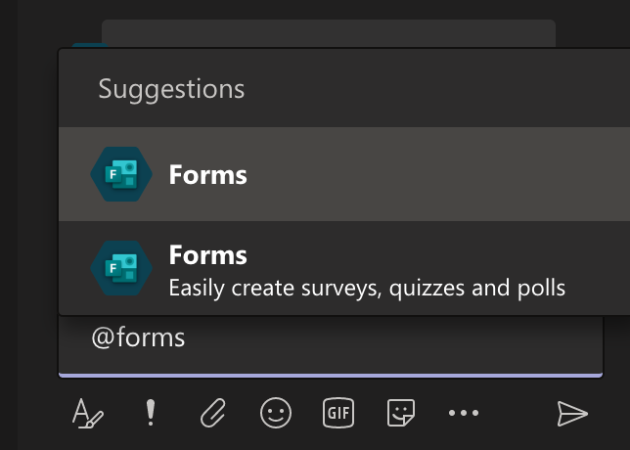 | 