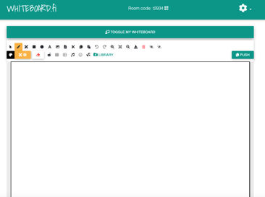
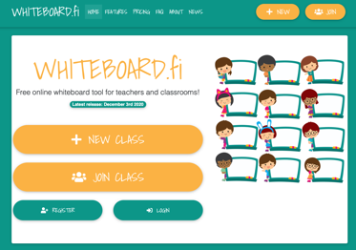
Using Whiteboard Fi
If you want to use a free set of mini whiteboards in your lesson that don’t require login

Go to this link https://whiteboard.fi
Click on the link above (just before the lesson as the room only lasts 2 hours)

and then click NEW CLASS

you’ll see a box like the one to the left

Type the name you’d like to appear
EG “Miss Konstantine”

You can decide if you want a waiting room lobby or not. Might be a good idea to and then you can monitor the names of students attending

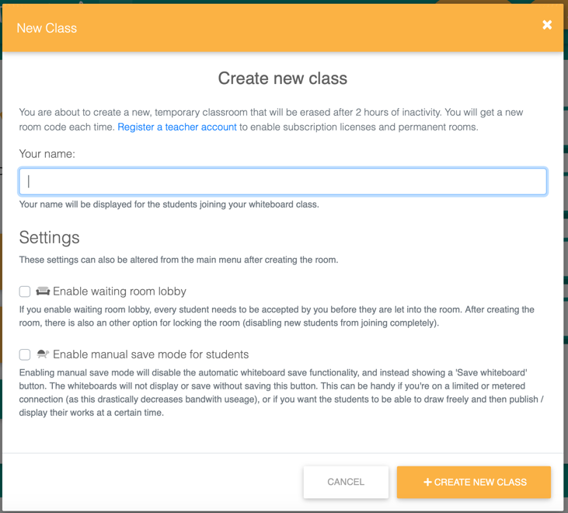

Copy the link you receive so for this meeting it is:

https://whiteboard.fi/t2934
and paste it into the chat on your TEAMS meeting. You could present a slide in TEAMS like the one below to make sure all students are aware of the rules.
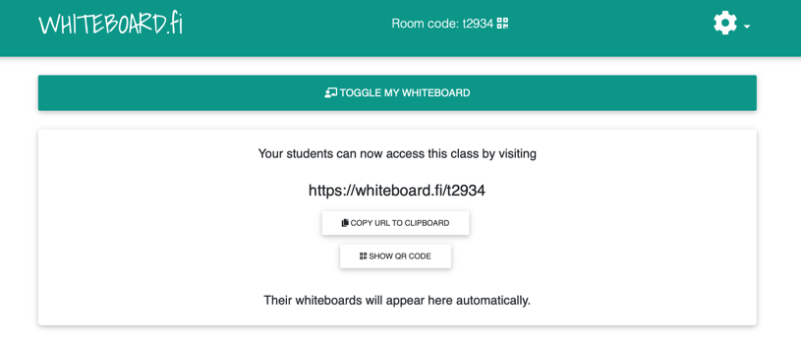

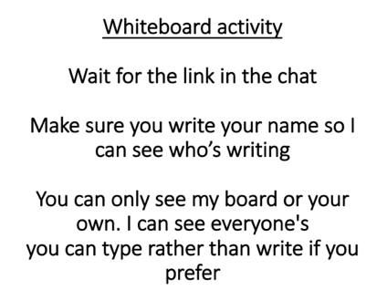
Once you press toggle my whiteboard you will see the screen below.
You can either upload a screen shot of a question you want to ask or write or type one.
Then PUSH your whiteboard screen means the students can all see what you have written. They can only see your work and their but not each other’s.

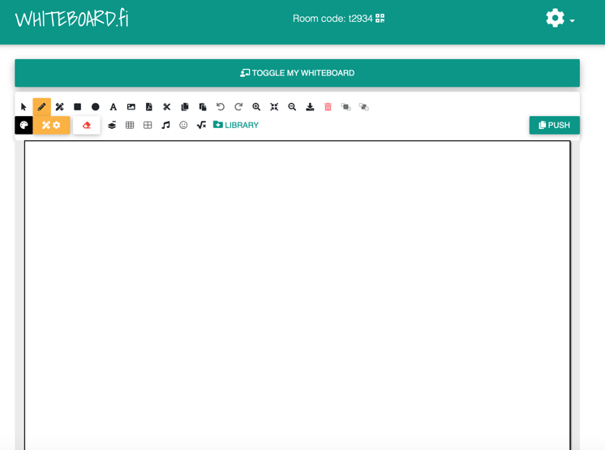
Some tips for using Whiteboard Fi

- You can open the “room” for 2 hours so if you want to set your room up beforehand you can have the link ready to share in the chat

- You are given a room code EG: t4765, that you can give students if they would rather access the website on a different device and have TEAMS open on their laptop.

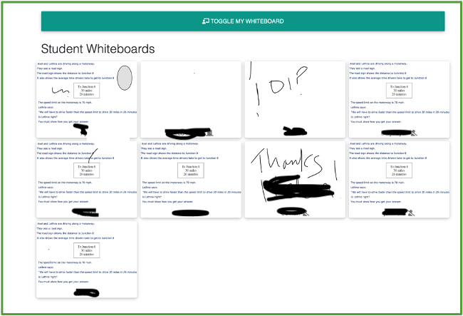
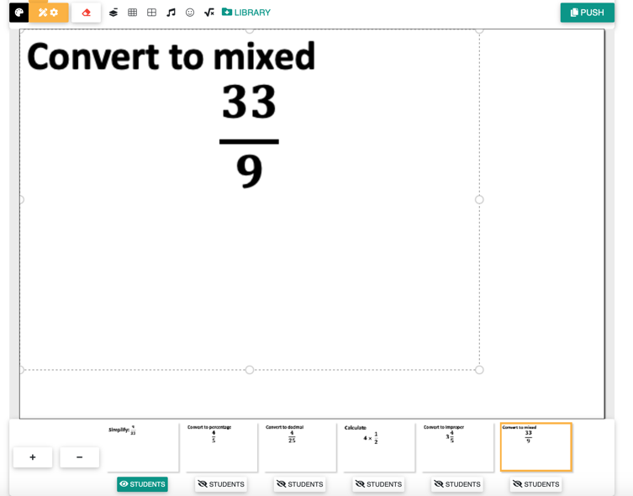
- You can set up lots of whiteboard slides ahead of the lesson with prepared questions. There’s an example below. Notice how the slides cannot be viewed unless you select them and “push current slide”

- You can copy any students work to your own whiteboard and then share that with the whole class. The image on left is from Ajay Chokshi’s lesson. He said that he shared one of the student’s board because they had drawn an excellent diagram for bearings. The image on the right is an example of a “pushed board” with students work on (pushed to all students as a good EG)
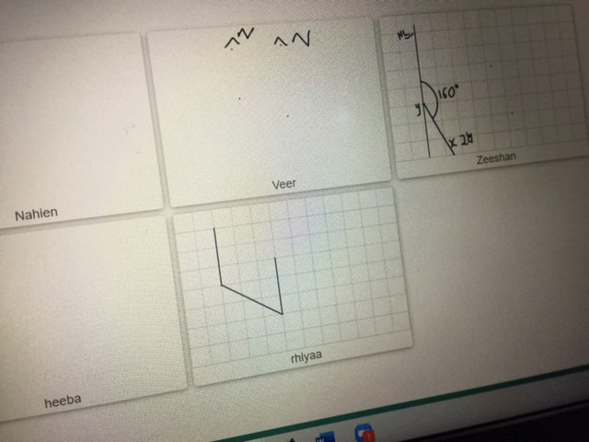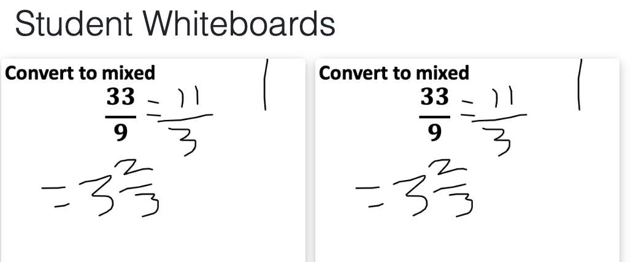
TO DO THIS: click on any student’s board and then select “copy to teacher whiteboard” you can then “push” this to all students.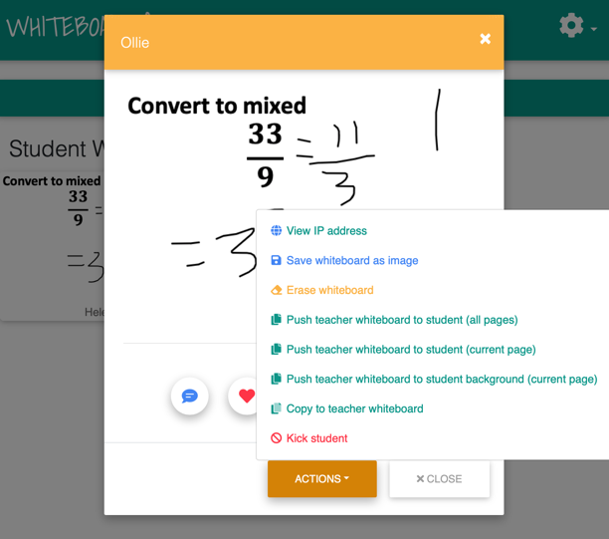
I am happy to support with using this website; whether that is by inviting you to one of my lessons or possibly it would be of more use if you set up a classroom and sent me the link so you could see what the student’s boards are like and how to interact with them (I could pose as a student)

